Instructional Continuity
Lackland ISD’s
Leveraging Learning
Plan

Table of Contents
0
Overarching Goals 4
Stakeholder Input 4
Survey I (linked here) 4
Stakeholder Input Round II 6
7
Student Survey and Responses 7
Teacher Survey and Responses 7
Staff Survey and Responses 7
Achievement Data and Analysis 8
First Grade 8
First Grade Achievement Profile 8
Second Grade 9
Second Grade Achievement Profile 9
Third Grade 10
Third Grade Math Achievement Profile 10
Third Grade Reading Achievement Profile 10
Third Grade Needs Assessment 10
Fourth Grade 11
Fourth Grade Math Achievement Profile 11
Fourth Grade Reading Achievement Profile 11
Fourth Grade Needs Assessment 11
Fifth Grade 12
Fifth Grade Math Achievement Profile 12
Fifth Grade Reading Achievement Profile 12
Fifth Grade Needs Assessment 12
Sixth Grade 13
Sixth Grade Math Achievement Profile 13
Sixth Grade Reading Achievement Profile 13
Sixth Grade Needs Assessment 13
Seventh Grade 14
Seventh Grade Math Achievement Profile 14
Seventh Grade Reading Achievement Profile 14
Seventh Grade Needs Assessment 14
Eighth Grade 15
Eighth Grade Math Achievement Profile 15
Eighth Grade Reading Achievement Profile 15
Eighth Grade Needs Assessment 15
Algebra I 16
Algebra I Achievement Profile 16
Algebra I Needs Assessment 16
English I 17
English I Achievement Profile 17
English I Needs Assessment 17
English II 18
English II Achievement Profile 18
English II Needs Assessment 18
Biology 19
Biology Achievement Profile 19
Biology Needs Assessment 19
History 20
History Achievement Profile 20
History Needs Assessment 20
Appendix A - Survey 21
Stakeholder Input Communication I 21
ESSER III Grant Stakeholder Input Survey 22
Teacher ESSER Survey and Results - Round II 33
Staff ESSER Survey and Results - Round II 41
Appendix B - Achievement Data 45
First Grade 45
First Grade Math 45
Second Grade 47
Second Grade Math 47
Second Grade Reading 49
Third Grade 51
Third Grade Math 51
Third Grade Reading 52
Fourth Grade 53
Fourth Grade Math 53
Fourth Grade Reading 54
Fifth Grade 55
Fifth Grade Math 55
Fifth Grade Reading 56
Sixth Grade 57
Sixth Grade Math 57
Sixth Grade Reading 58
Seventh Grade 59
Seventh Grade Math 59
Seventh Grade Reading 60
Eighth Grade 61
Eighth Grade Math 61
Eighth Grade Reading 62
Algebra I 63
English I 64
English II 65
Biology 66
History 67

Overarching Goals

Campus | Goals
District | Student grade level achievement results will rebound to achievement levels earned during the 2018-2019 school year for the 2021-2022 school year and sustained to meet goals related to closing the achievement gaps.
Lackland Elementary | Elementary students will continue to make 5% gains in each grade level reporting category to rebound to 2019 scores.
Stacey Jr/Sr High School | Students grade levels will attain 5% growth in achievement on STAAR in Approaches, Meets, and Masters categories.

Stakeholder Input

Survey I (linked here)
The Lackland Leverage Learning plan component Survey I engaged 189 participants. This survey shows the primary category and secondary category selected by the stakeholder.
The following graphs reflect participant responses to survey questions.

Stakeholder Input Round II
To gain input from our stakeholders, Lackland ISD utilized two rounds of input, a quantitative survey round and a qualitative free-response round.
Analysis of Survey Round II
In the first round, a survey was distributed to parents, students, teachers, and staff via an online web form. Those responding to the survey answered questions by selecting from a list of pre-defined options. Each question contained an “other” option that allowed the respondent to provide additional information. A screenshot of the survey is included in Exhibit A at the end of this plan.
Data in this survey were then tabulated by answer choice to determine the number of respondents who had selected a particular answer choice. These were then rank-ordered by those choices receiving the greatest number of responses.
Analysis of Free-Response Questions Round II

Based on the results from the survey round, the district asked our students, our teachers, and our staff free-response questions during a second round of stakeholder input. The individuals in these groups typed their answers to these questions into a web-based form.
We applied qualitative research methods to these responses in order to visualize themes across all those who responded. Sentences and sections of each individual’s response were highlighted and categorized under a code. If a number of individuals mentioned the same or a similar concept, then that was determined to be a theme. In general, themes are discussed from those that are most strong to those that are least strong. In other words, if more individuals discussed a theme, that theme is discussed first.
Numbers appearing before a quote from an individual are merely a citation: they do not indicate frequency in any way.

Student Survey and Responses

Teacher Survey and Responses

Staff Survey and Responses

Achievement Data and Analysis

First Grade

First Grade Achievement Profile

Second Grade

Second Grade Achievement Profile

Third Grade

Third Grade Math Achievement Profile

Third Grade Reading Achievement Profile

Third Grade Needs Assessment
Strengths | Weaknesses | Strategies (ESSER Type) | Resources
Reading  R1 Understand a variety of written texts across genres-82.2%  Math  R1 Numerical Representations and Relationships-72.07%  R4 Data Analysis and Personal Financial Literacy-64.2% | Reading  R2 Understand and analyze literary texts-62.8%  R3 Understand and analyze informational texts-64.29%  Math  R2 Computations and Algebraic Relationships-59.54%  R3 Geometry and Measurement-52.2% | Summer Enrichment Camps (Library, GT, Yoga, Art, Arts & Crafts, Dance, Theatre)  Reading Academy  Elementary PD Plan  Math PD: August 2-6  Success for All Reading Roots (New Edition): August 2 | Literably

Fourth Grade

Fourth Grade Math Achievement Profile

Fourth Grade Reading Achievement Profile

Fourth Grade Needs Assessment
Strengths | Weaknesses | Strategies (ESSER Type) | Resources
Reading  R1 Understand a variety of written texts across genres-70.04%  Math  R1 Numerical Representations and Relationships-67.02%  R2 Computations and Algebraic Relationships-60.17% | Reading  R2 Understand and analyze literary texts-62.8%  R3 Understand and analyze informational texts-64.29%  Math  R3 Geometry and Measurement-50.95%  R4 Data Analysis and Personal Financial Literacy-54.76% | Summer Enrichment Camps (Library, GT, Yoga, Art, Arts & Crafts, Dance, Theatre)  Reading Academy  Elementary PD Plan  Math PD: August 2-6  Success for All Reading Roots (New Edition): August 2 | Literably

Fifth Grade

Fifth Grade Math Achievement Profile

Fifth Grade Reading Achievement Profile

Fifth Grade Needs Assessment
Strengths | Weaknesses | Strategies (ESSER Type) | Resources
Reading  R1 Understand a variety of written texts across genres-72.2%  Math  R2 Computations and Algebraic Relationships-70.41%  R3 Geometry and Measurement-64.34%  R4 Data Analysis and Personal Financial Literacy-70.52% | Reading  R2 Understand and analyze literary texts-76.21%  R3 Understand and analyze informational texts-81.13%  Math  R1 Numerical Representations and Relationships-57.96% | Summer  Enrichment Camps (Library, GT, Yoga, Art, Arts & Crafts, Dance, Theatre)  Reading Academy  Elementary PD Plan  Math PD: August 2-6  Success for All Reading Roots (New Edition): August 2 | Literably

Sixth Grade

Sixth Grade Math Achievement Profile

Sixth Grade Reading Achievement Profile

Sixth Grade Needs Assessment
Strengths | Weaknesses | Strategies (ESSER Type) | Resources
Math - RC 3 62% (Geometry & Measurement) RC 4 63% (Data Analysis & Personal Financial Literacy)  Reading – RC 2 78% (Understanding & Analysis of Literary Texts) | Math – RC 1 55% Numerical Relationships & Representations  RC 2 – 56% Computations & Algebraic Relationships | After School Tutoring – Tuesday/Thursday  B2 - $30/Hr  Collaborative Wednesday – Curriculum Writing/Compacting  B2 - $25/Hr | IStation 6 –8 Math/Reading  ALEKS 6-8  Edmentum Plato Courseware 6-8  Chalk Curriculum Mapping

Seventh Grade

Seventh Grade Math Achievement Profile

Seventh Grade Reading Achievement Profile

Seventh Grade Needs Assessment
Strengths | Weaknesses | Strategies (ESSER Type) | Resources
Math – RC 3 62% (Geometry & Measurement)  Reading – RC 1 79% (Understanding & Analysis Across Genres) RC 2 73% (Understanding & Analysis of Literary Texts) | Math – RC 4 42% (Data Analysis & Personal Financial Literacy) RC 2 46% (Computations & Algebraic Relationships) RC 1 49% (Probability & Numerical Relationships)  Reading – RC 3 71% (Understanding & Analysis of Informational Texts) | After School Tutoring – Tuesday/Thursday  B2 - $30/Hr  Collaborative Wednesday – Curriculum Writing/Compacting  B2 - $25/Hr | IStation 6 –8 Math/Reading  ALEKS 6-8  Edmentum Plato Courseware 6-8  Chalk Curriculum Mapping

Eighth Grade

Eighth Grade Math Achievement Profile

Eighth Grade Reading Achievement Profile

Eighth Grade Needs Assessment
Strengths | Weaknesses | Strategies (ESSER Type) | Resources
Math – RC 4 68% (Data Analysis & Personal Financial Literacy)  Reading – RC 1 85% (Understanding & Analysis Across Genres) RC 2 76% – Understanding & Analysis of Literary Texts | Math – RC 1 60% (Numerical Representations & Relationships) RC2 60% Computations & Algebraic Relationships RC 3 57% (Geometry & Measurement)  Reading – RC 3 73% Understanding & Analysis of Literary Texts | After School Tutoring – Tuesday/Thursday  B2 - $30/Hr  Collaborative Wednesday – Curriculum Writing/Compacting  B2 - $25/Hr | IStation 6 –8 Math/Reading  ALEKS 6-8  Edmentum Plato Courseware 6-8  Chalk Curriculum Mapping

Algebra I

Algebra I Achievement Profile

Algebra I Needs Assessment
Strengths | Weaknesses | Strategies (ESSER Type) | Resources
RC 1 67% (Number & Algebraic Methods) | RC 4 57% (Algebraic Functions & Equations) | After School Tutoring – Tuesday/Thursday  B2 - $30/Hr  Collaborative Wednesday – Curriculum Writing/Compacting  B2 - $25/Hr | Khan Academy  Edmentum Plato Courseware – Algebra I  Chalk Curriculum Mapping

English I

English I Achievement Profile

English I Needs Assessment
Strengths | Weaknesses | Strategies (ESSER Type) | Resources
RC 6 81% – Editing  RC 5 76% – Revision  RC 2 74% – Understanding & Analysis of Literary Texts | RC 4 54% - Composition | After School Tutoring – Tuesday/Thursday  B2 - $30/Hr  Collaborative Wednesday – Curriculum Writing/Compacting  B2 - $25/Hr | Khan Academy  Edmentum Plato Courseware – English I  Chalk Curriculum Mapping

English II

English II Achievement Profile

English II Needs Assessment
Strengths | Weaknesses | Strategies (ESSER Type) | Resources

Biology

Biology Achievement Profile

Biology Needs Assessment
Strengths | Weaknesses | Strategies (ESSER Type) | Resources
RC 5 77% – understanding of the interdependence & interactions that occur within an environmental system. | RC 1 58% – Understanding of Cells  RC 2 62% – Understanding of genetics | After School Tutoring – Tuesday/Thursday  B2 - $30/Hr  Collaborative Wednesday – Curriculum Writing/Compacting  B2 - $25/Hr | Khan Academy  Edmentum Plato Courseware – Biology I  Chalk Curriculum Mapping

History

History Achievement Profile

History Needs Assessment
Strengths | Weaknesses | Strategies (ESSER Type) | Resources
RC 2 88% –Understanding of geographic and cultural influences of US History  RC 4 85% – Understanding of economic and technological influences of US History | RC 3 81% – Understanding of the role of government and the civic process of US History | After School Tutoring – Tuesday/Thursday  B2 - $30/Hr  Collaborative Wednesday – Curriculum Writing/Compacting  B2 - $25/Hr | Khan Academy  Edmentum Plato Courseware – US History  Chalk Curriculum Mapping

Appendix A - Survey

Stakeholder Input Communication I
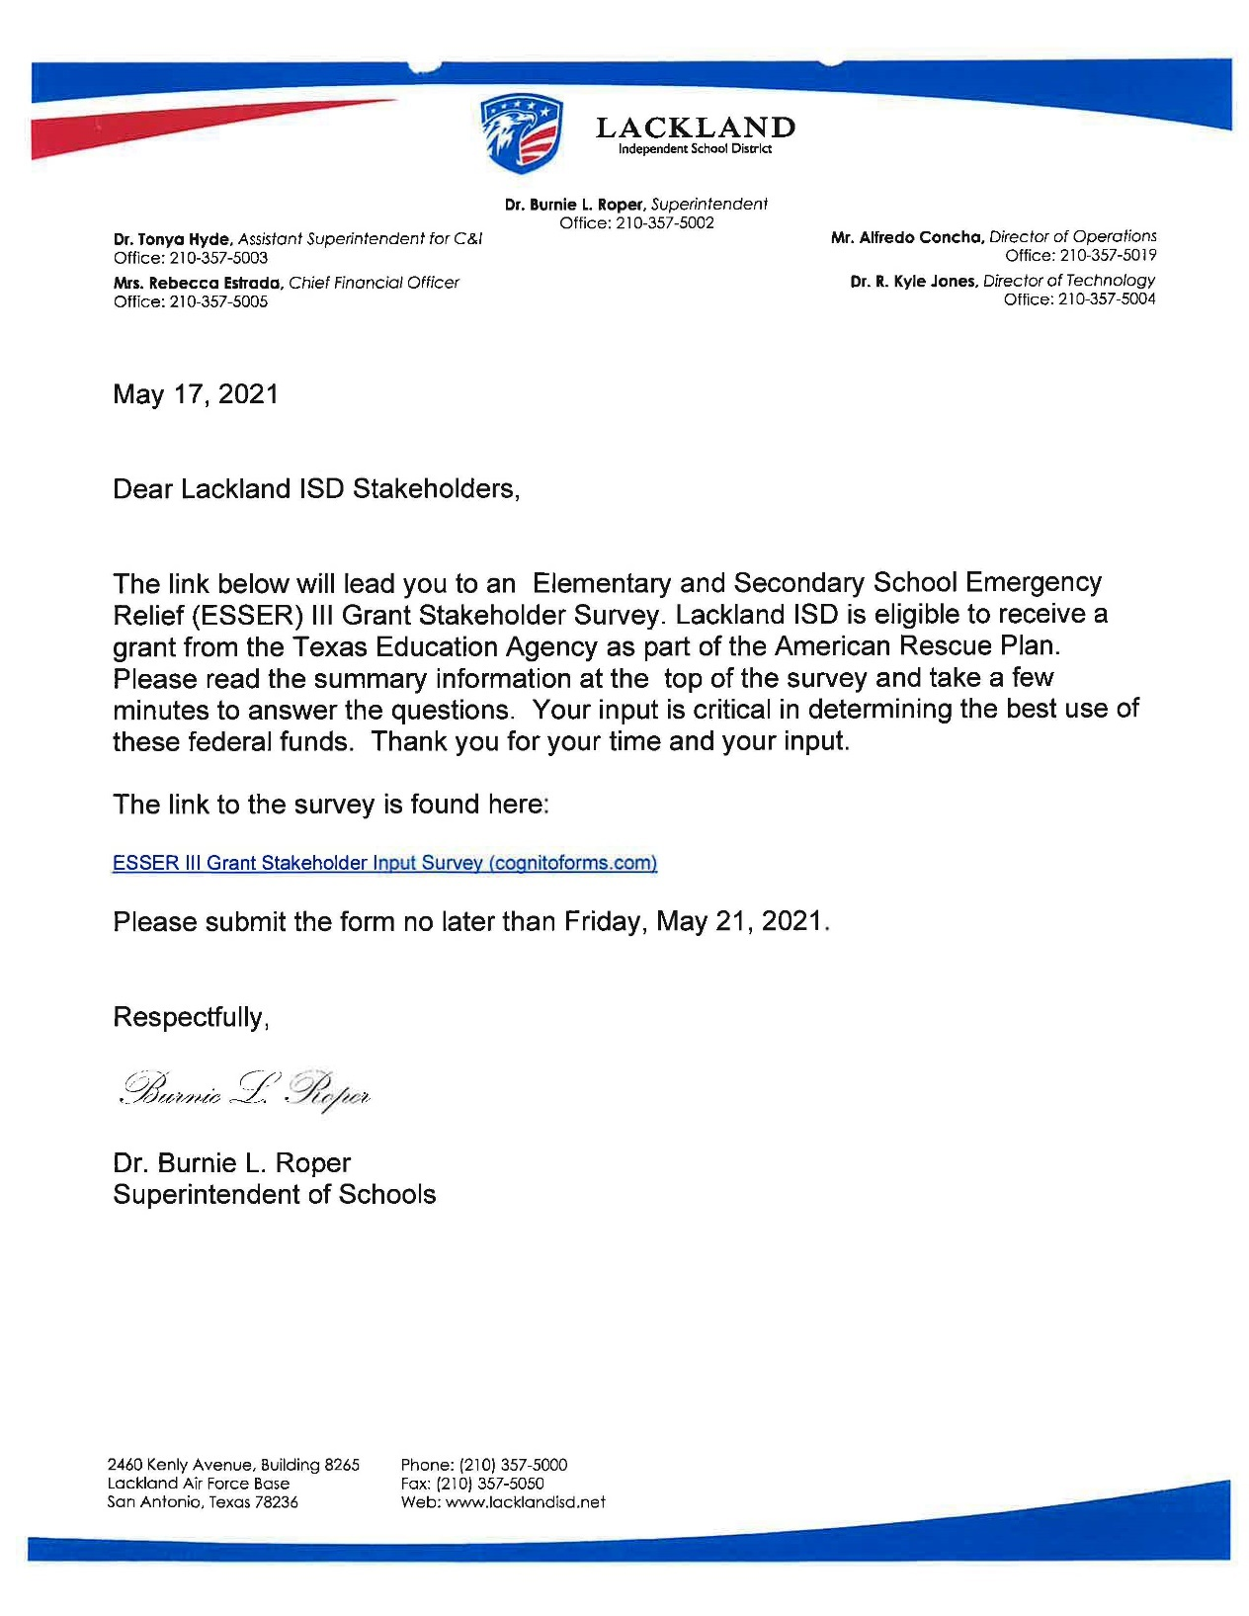

ESSER III Grant Stakeholder Input Survey
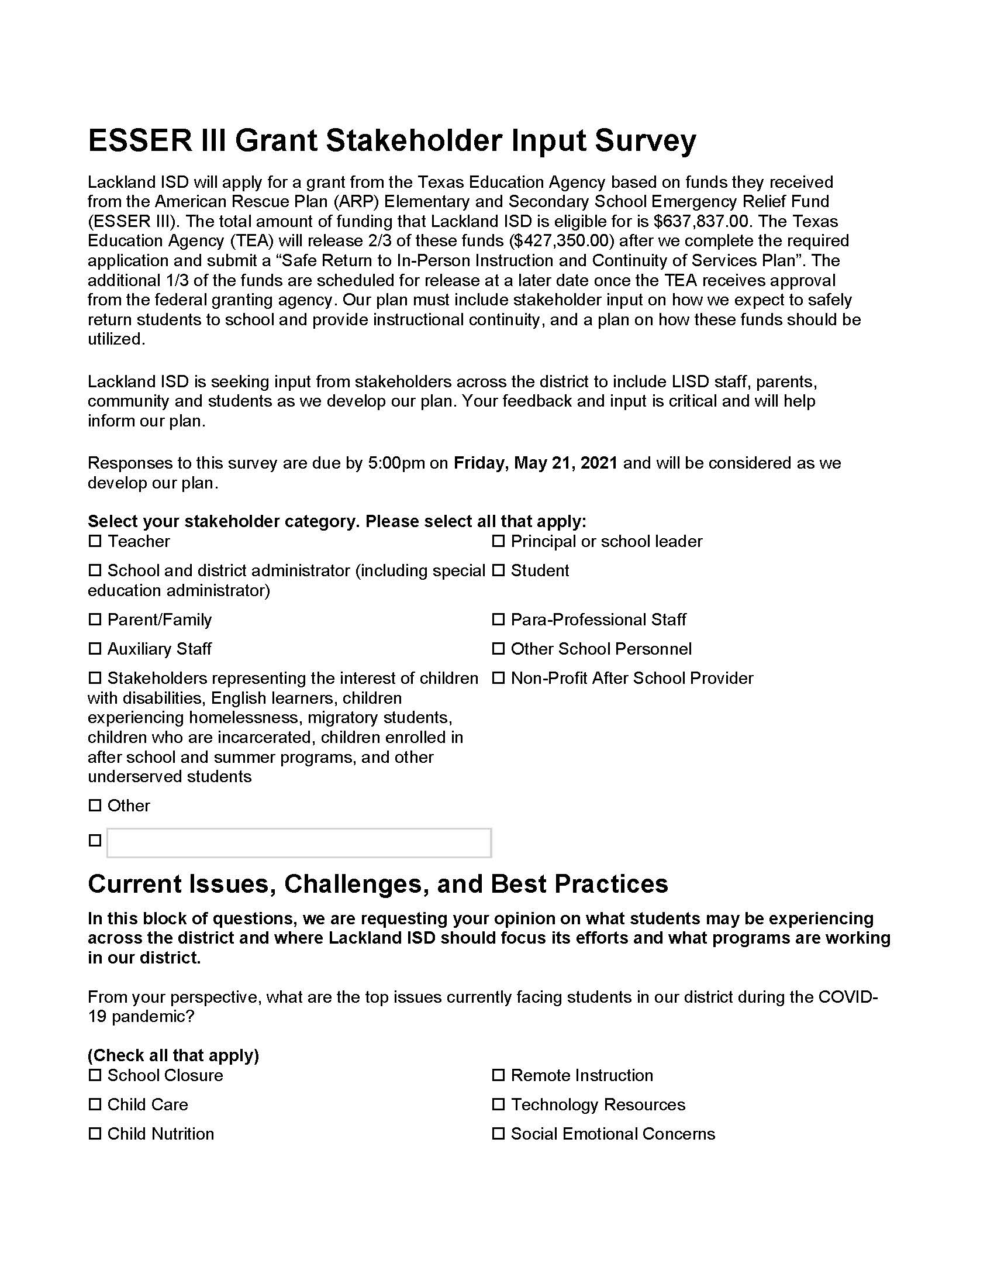
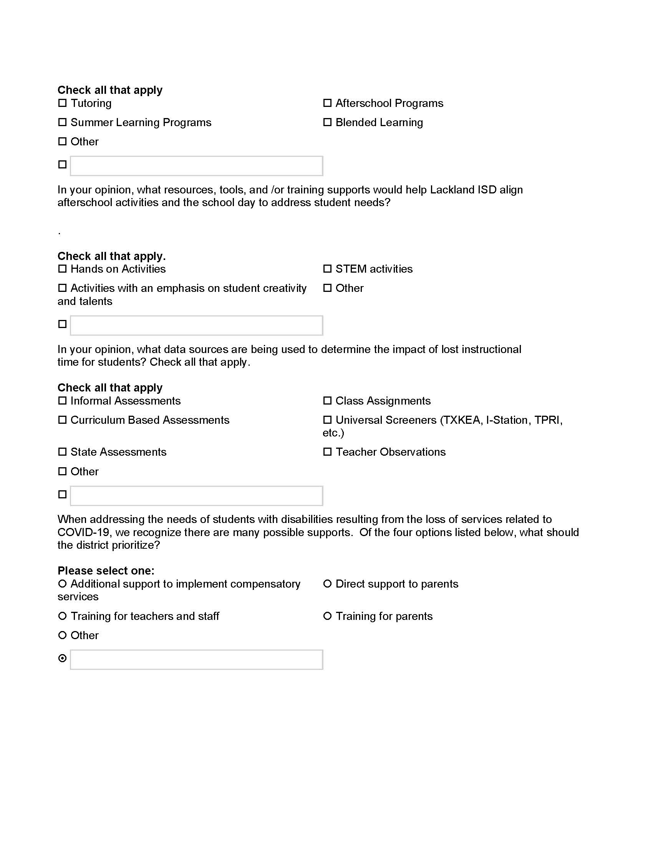

ESSER III - Student Survey Round II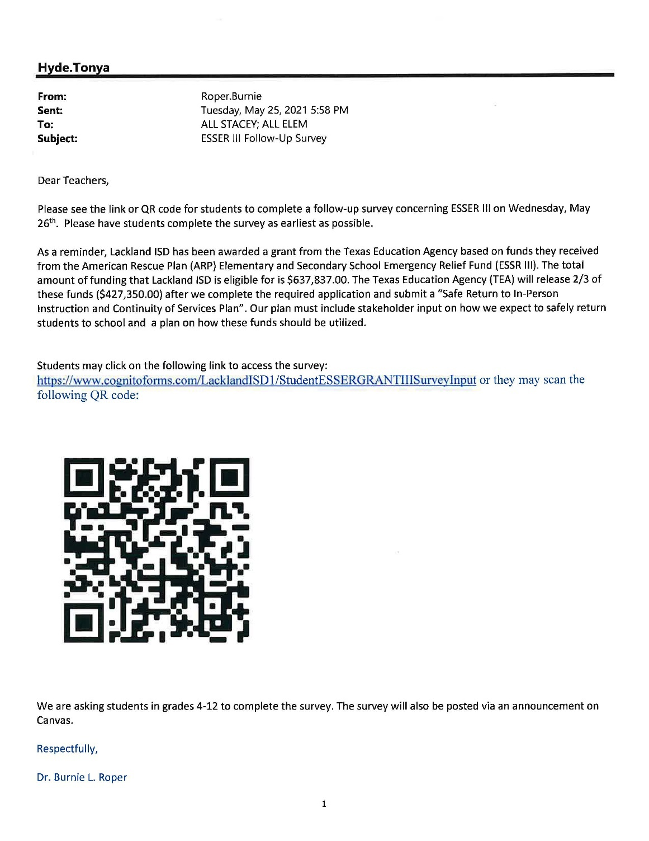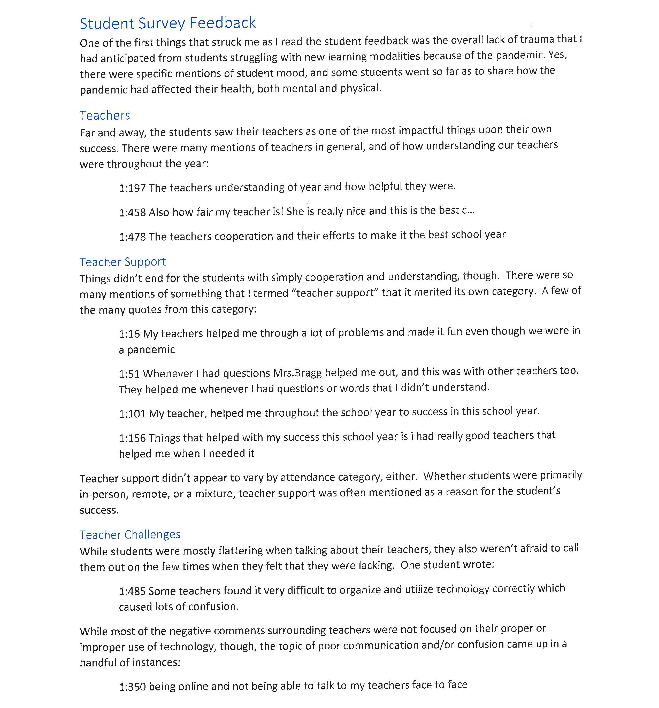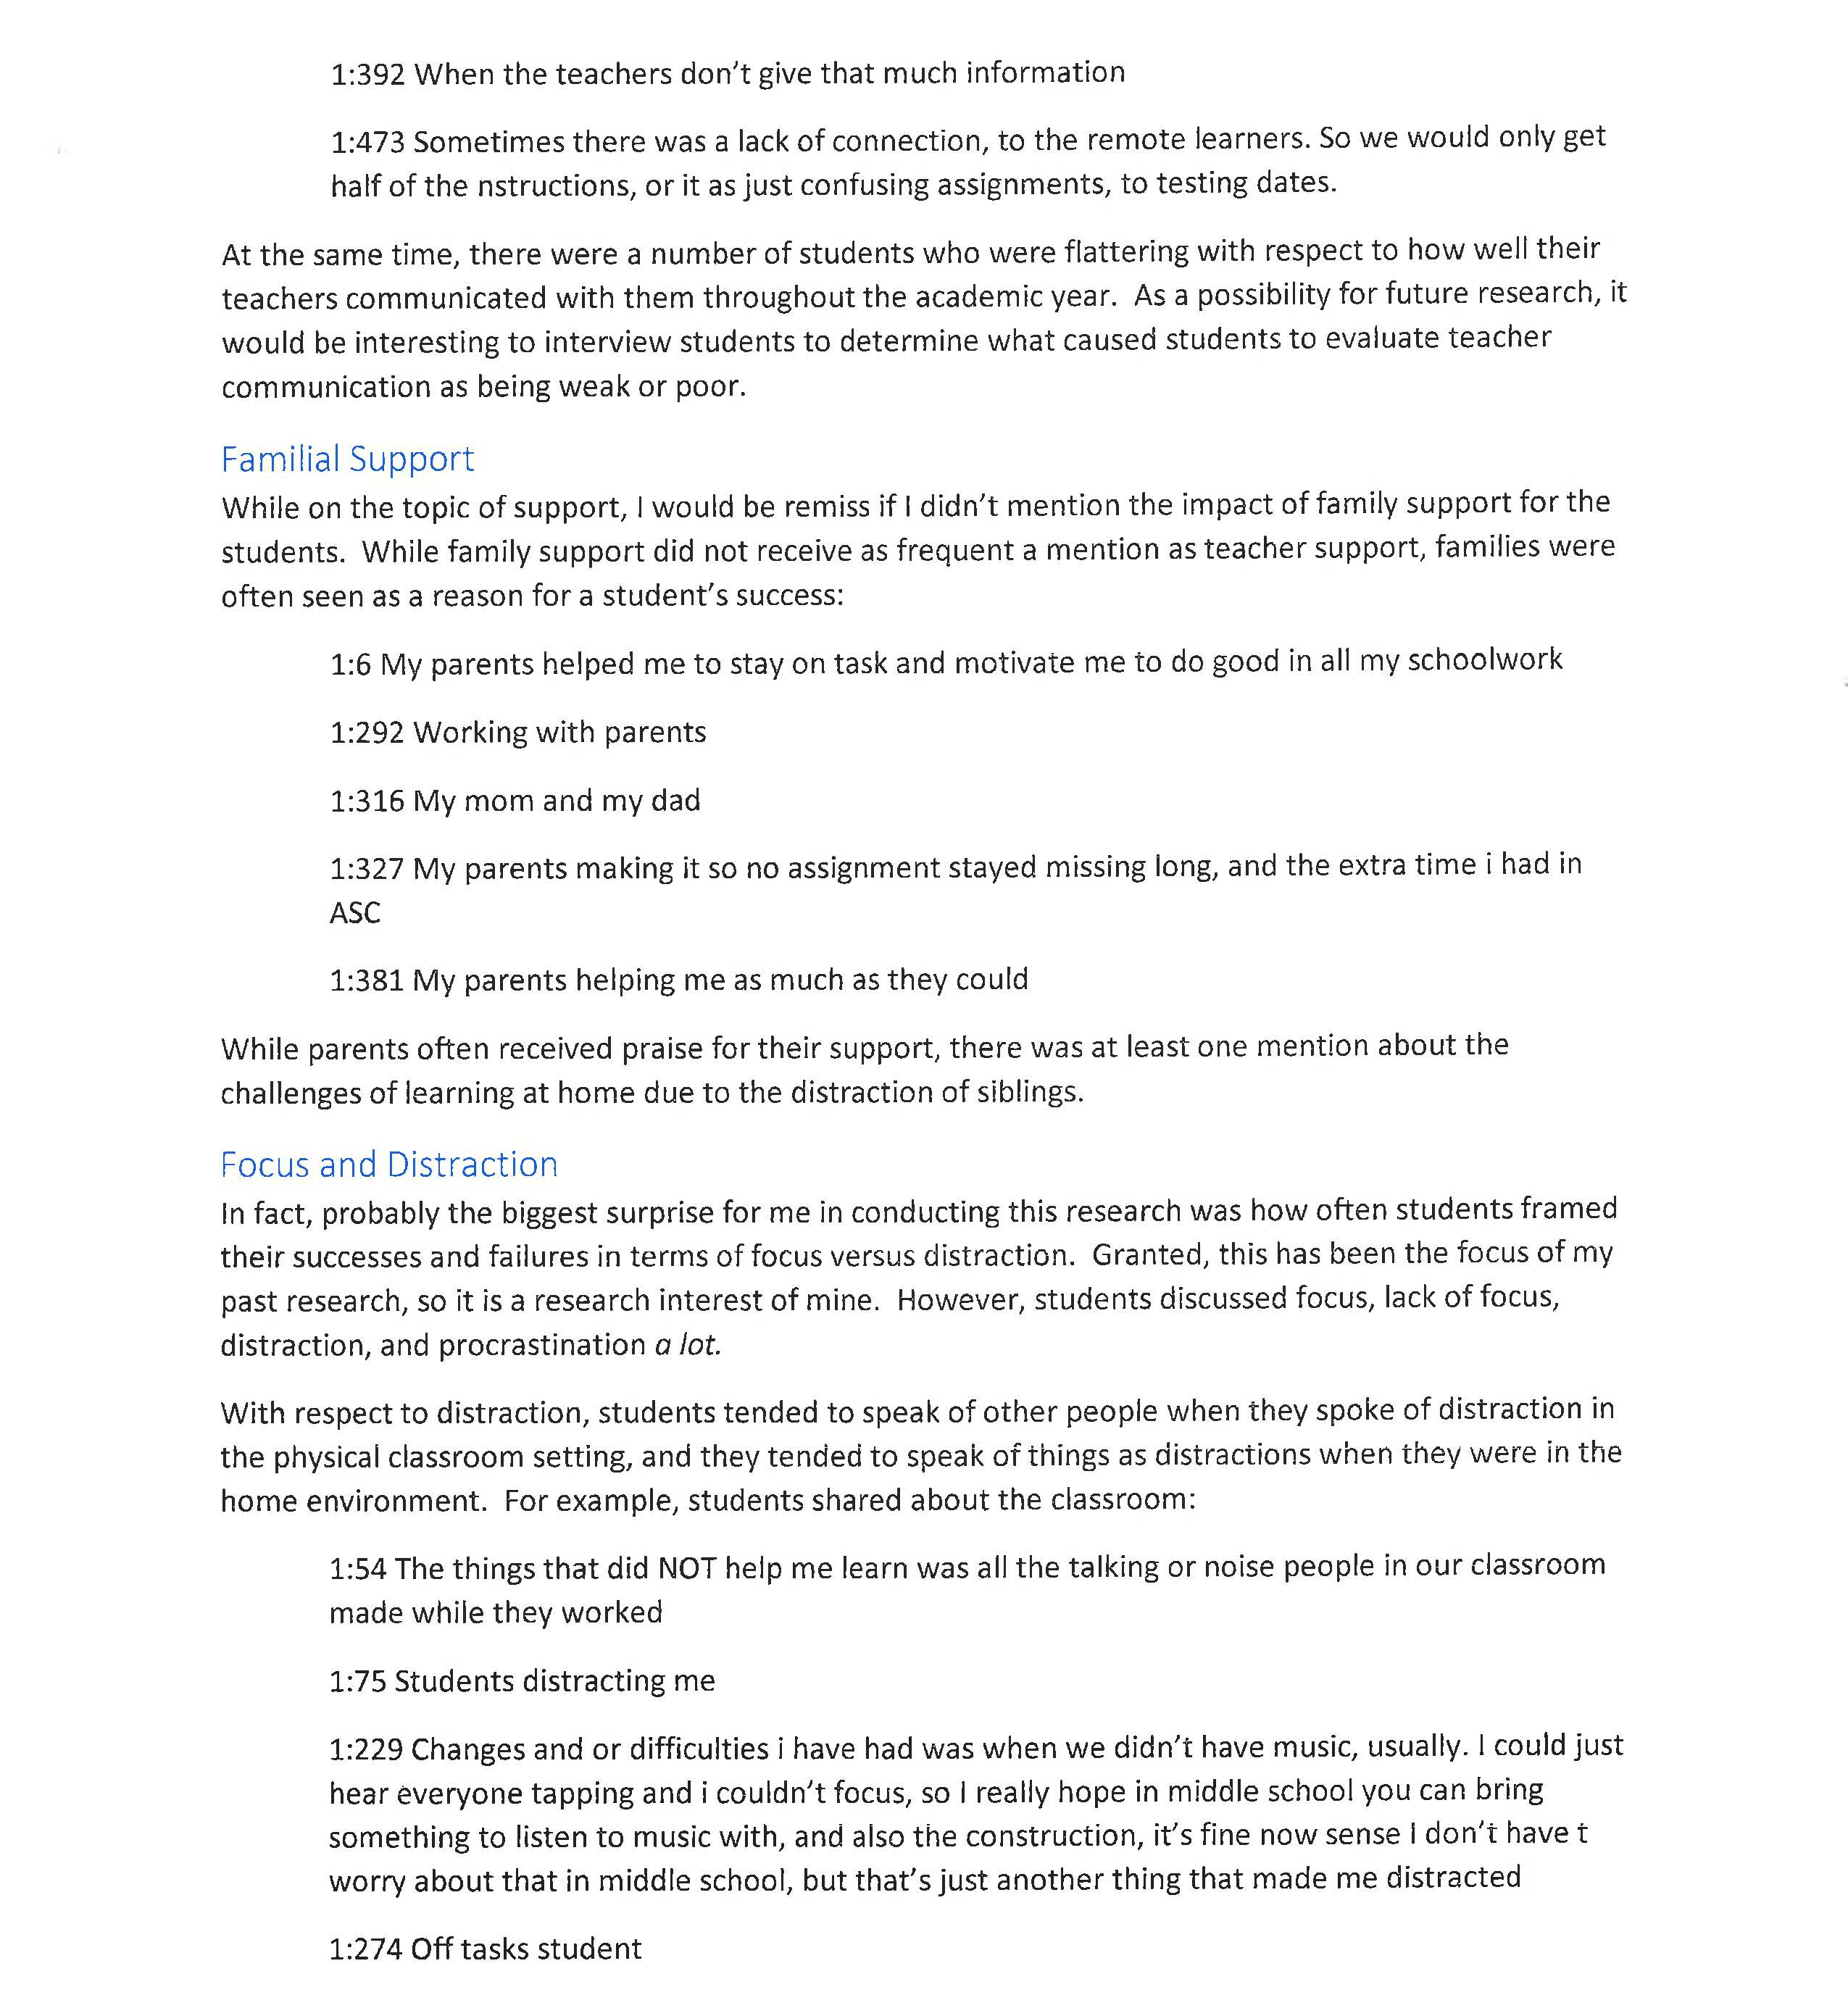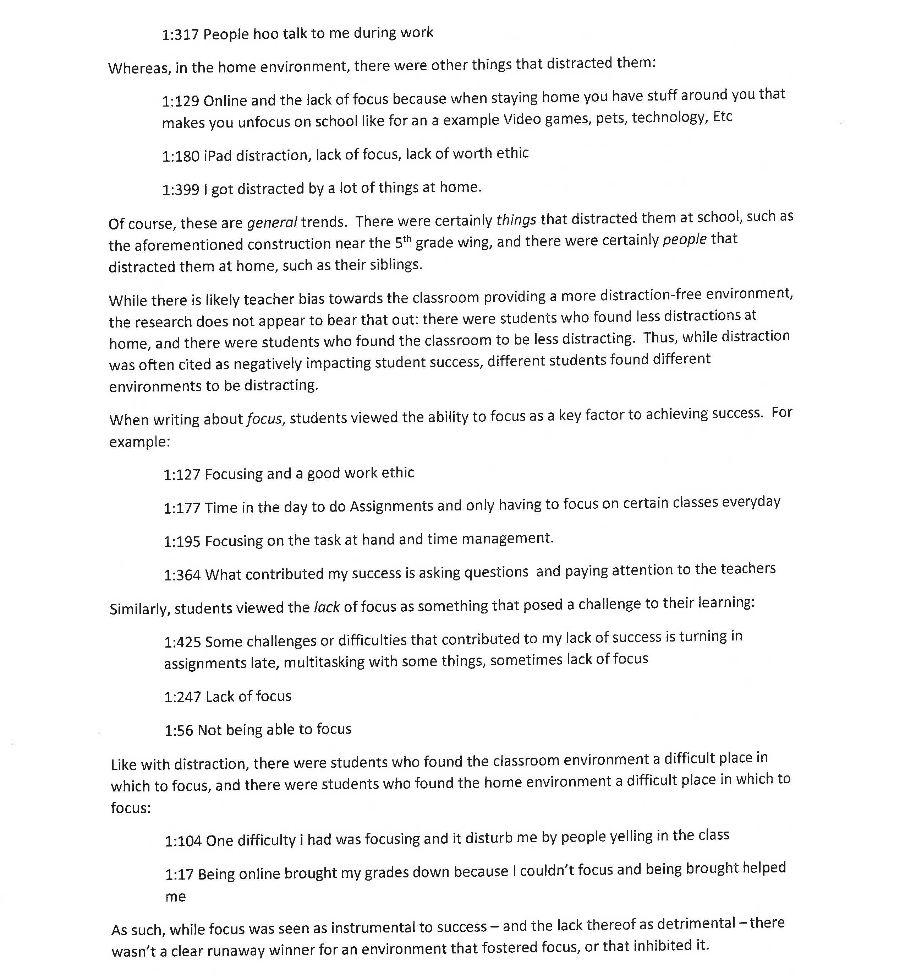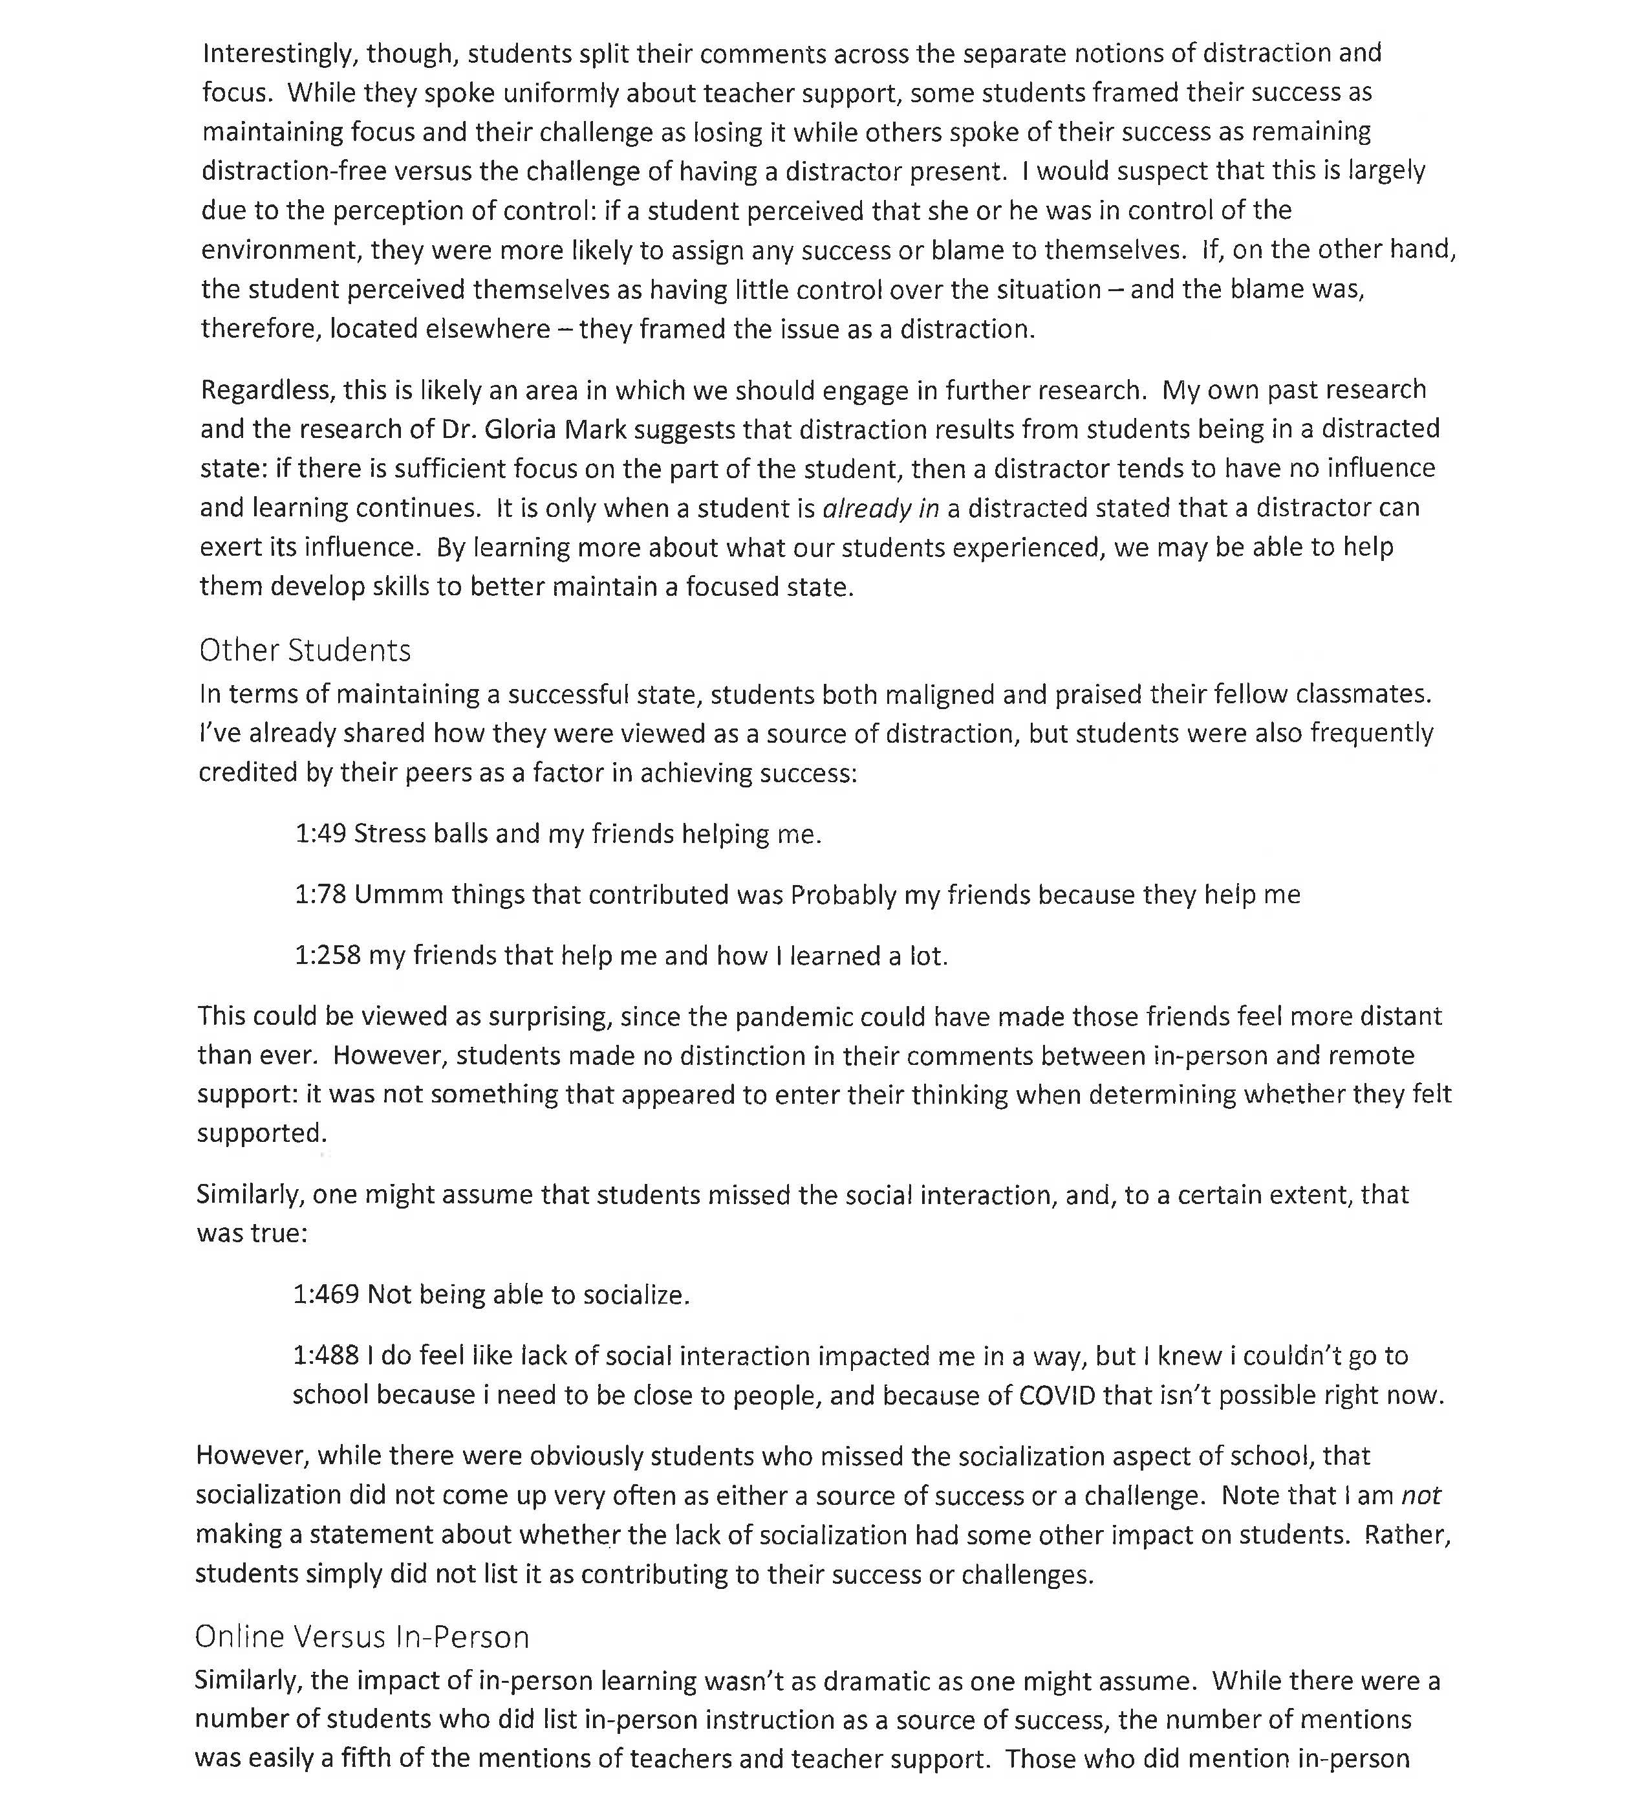

Teacher ESSER Survey and Results - Round II

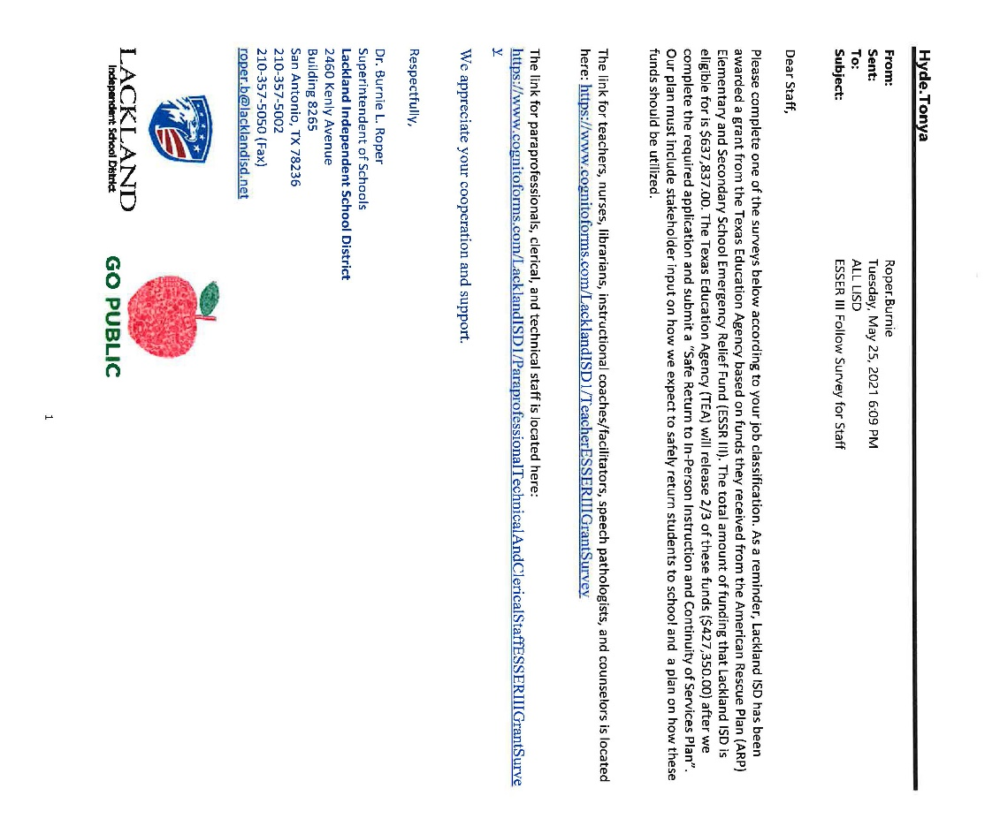
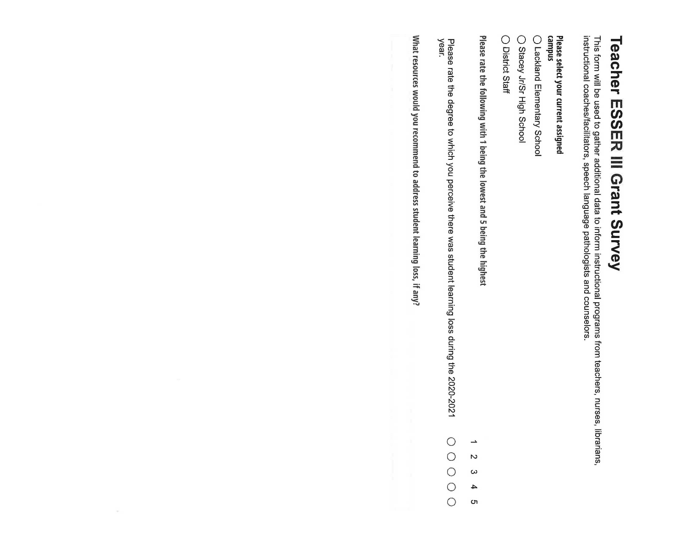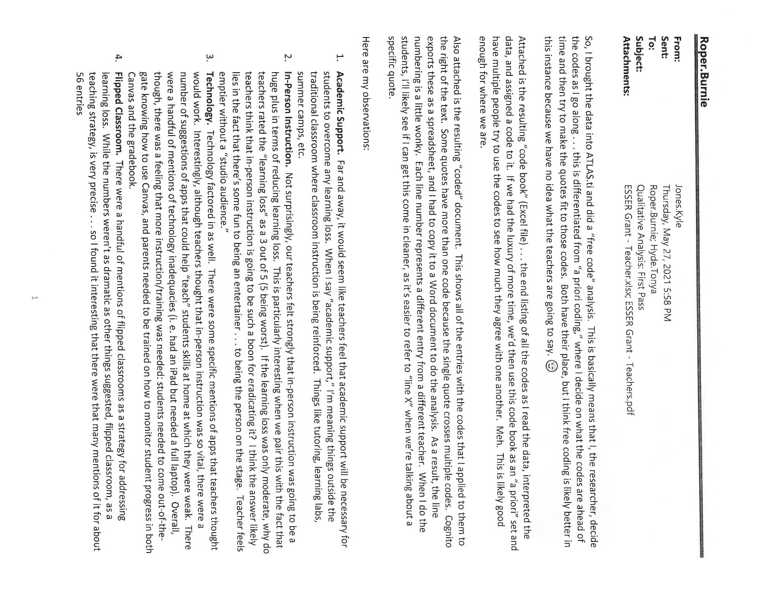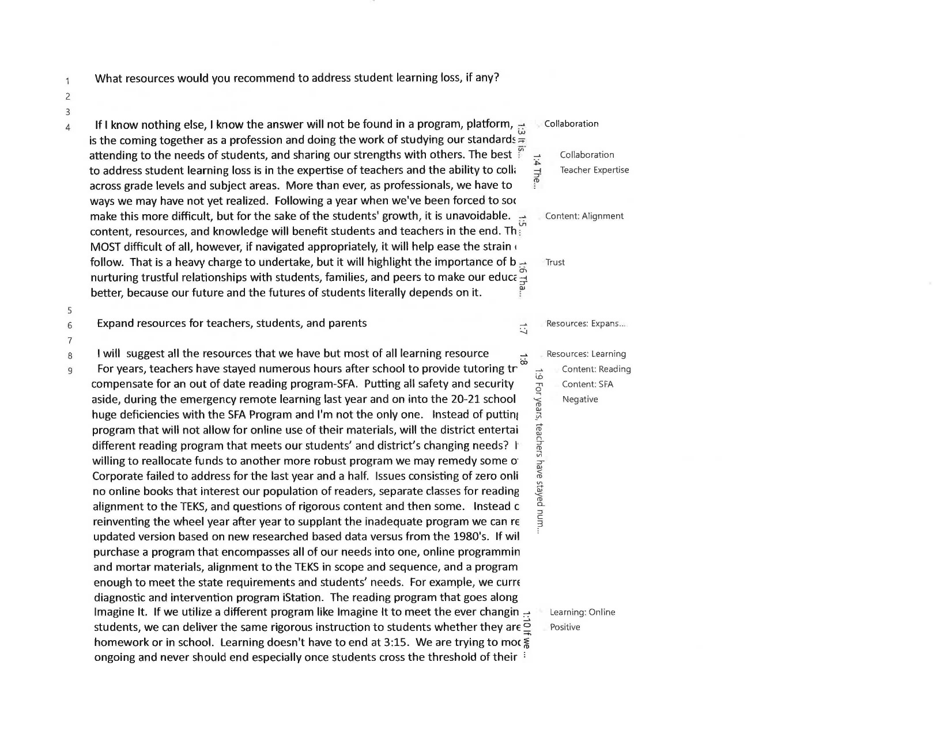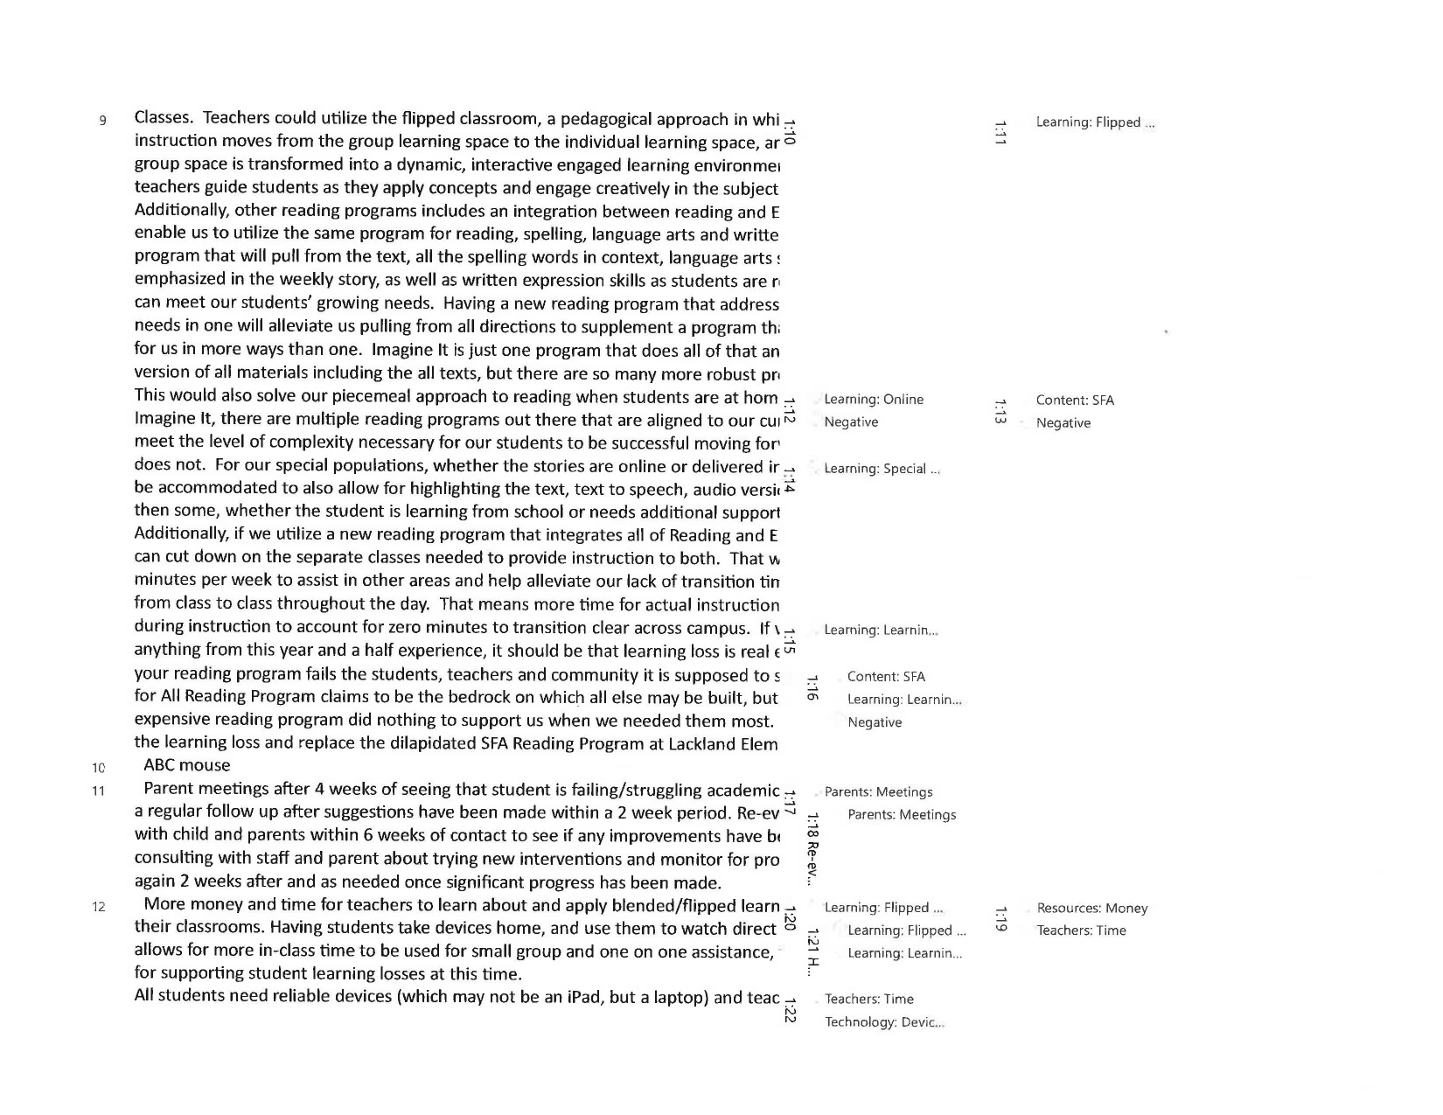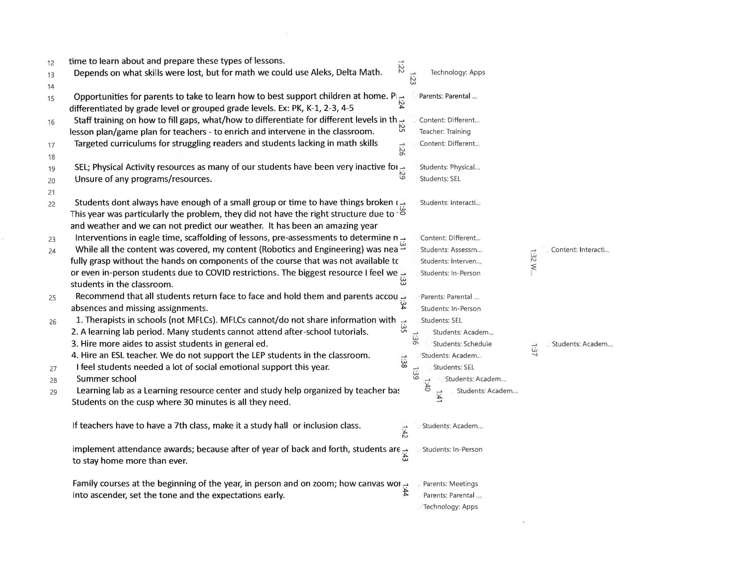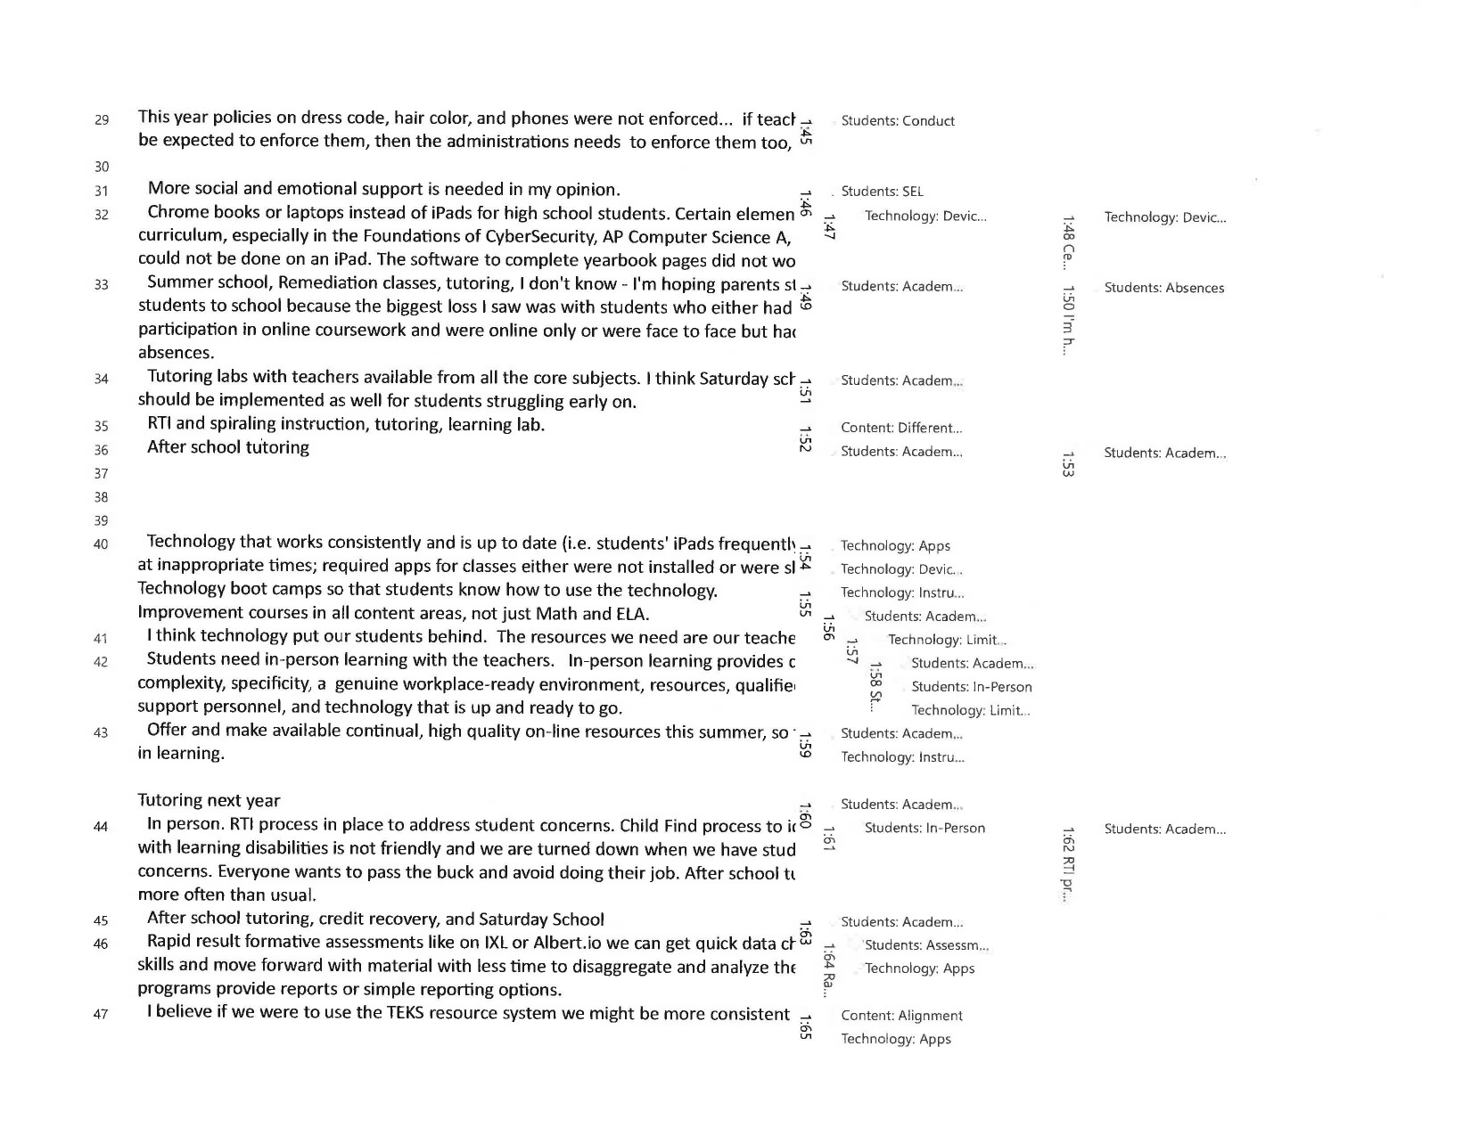

Staff ESSER Survey and Results - Round II

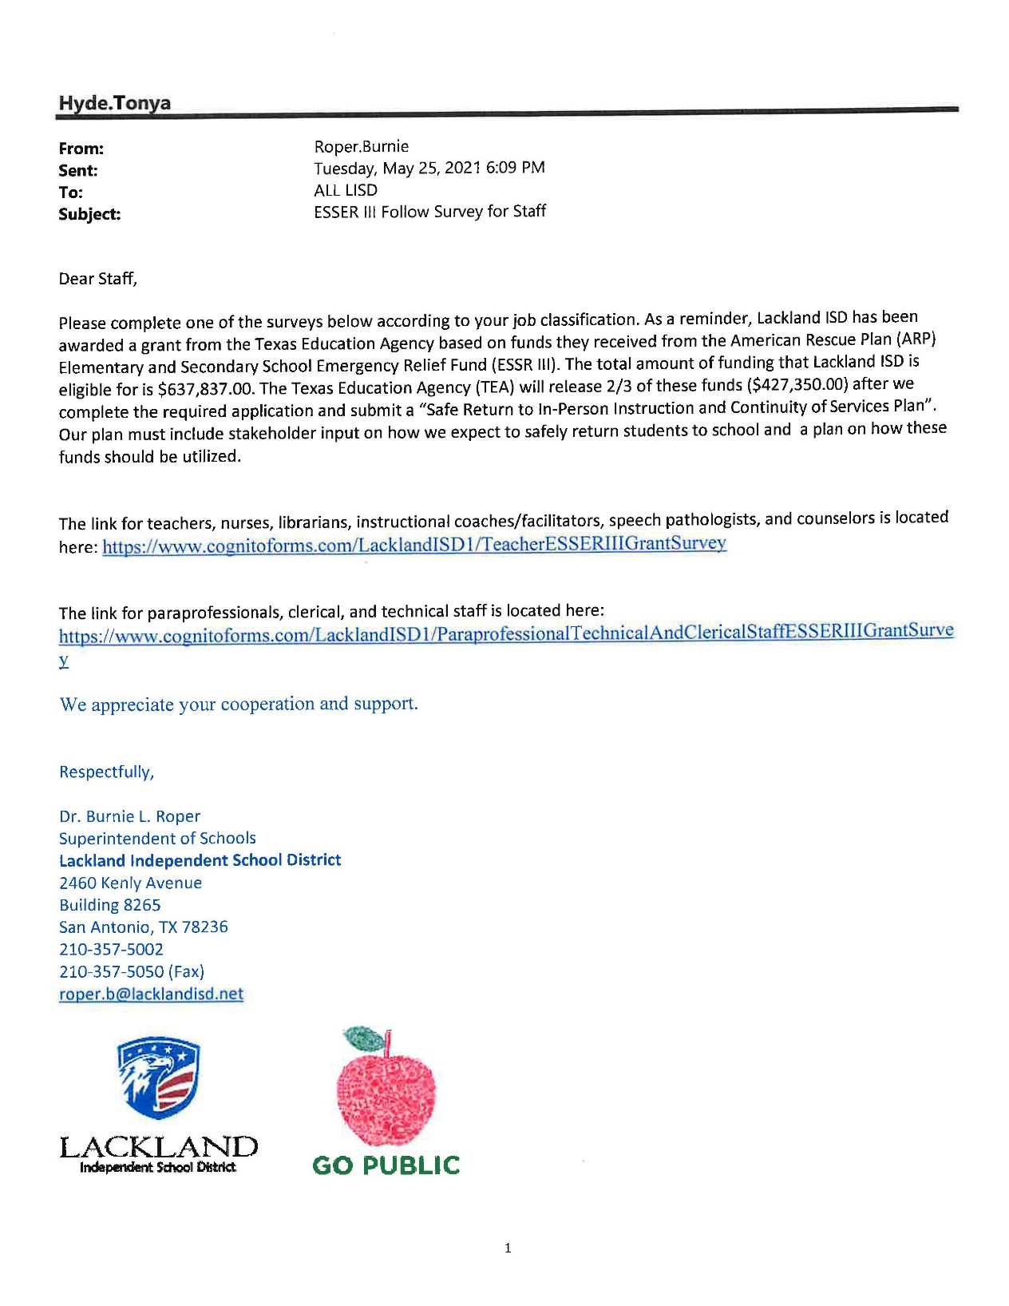
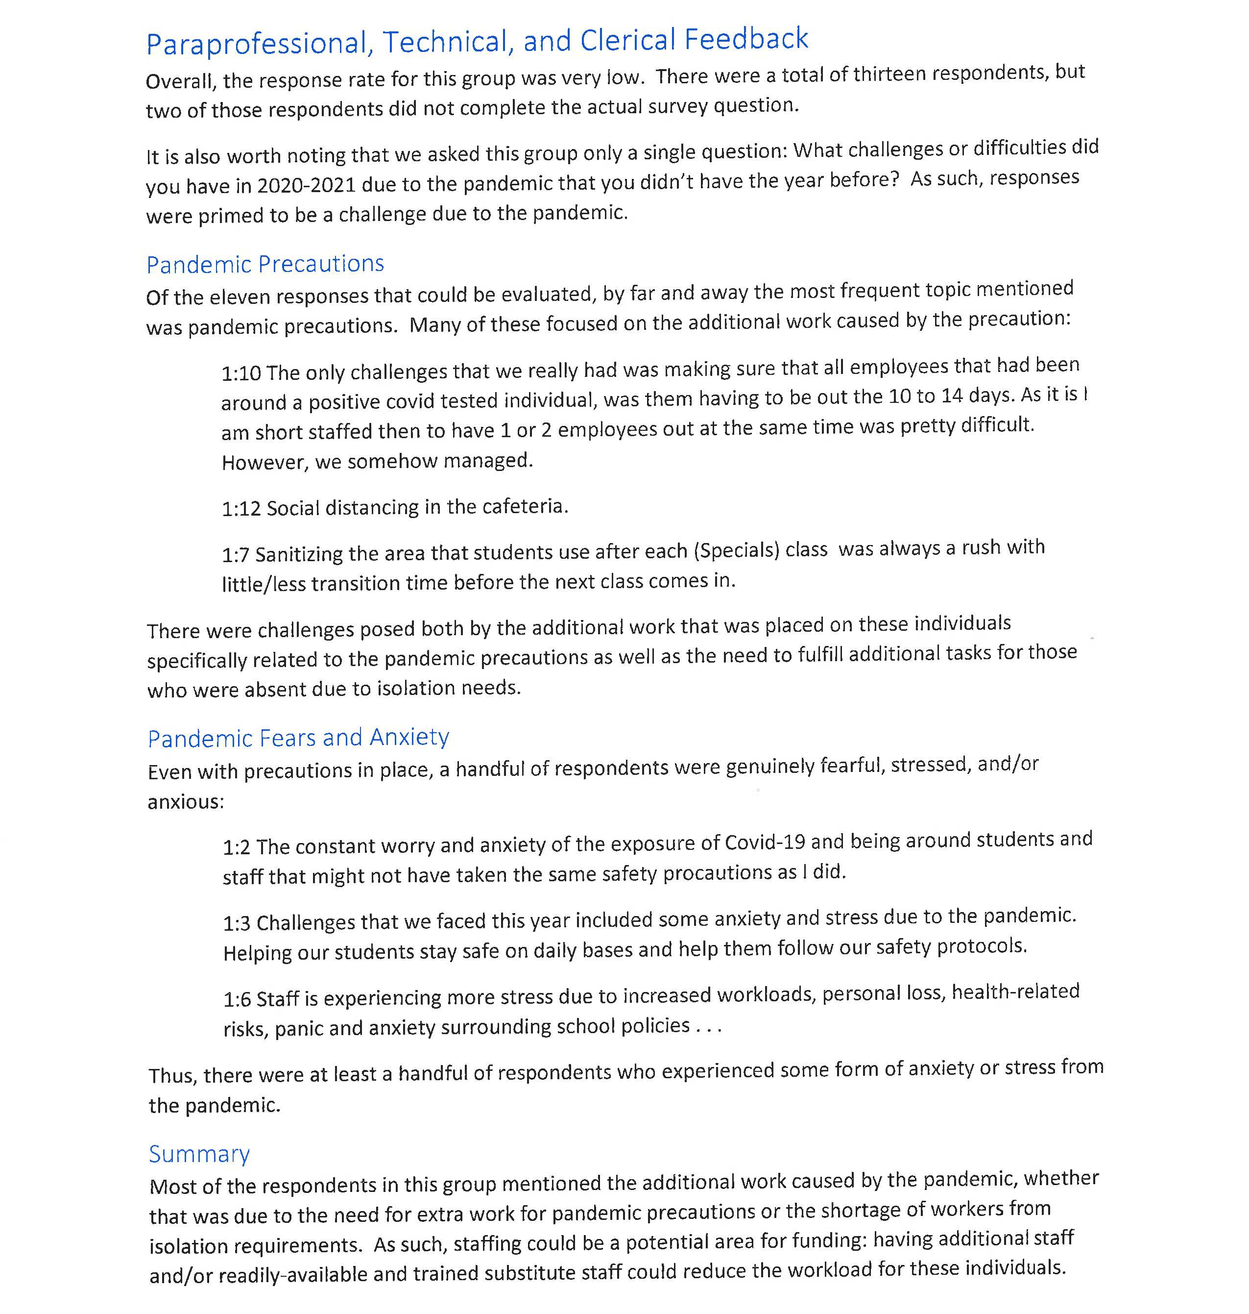

Appendix B - Achievement Data

First Grade

First Grade Math
 | 20-21 EOY  Mathematics 1 | 18-19 CA4 Mathematics 1
Elementary
Total Students | 72 | 106
Percent Score | 86.19% | 87.38%
Approaches | 98.61% | 98.11%
Meets | 79.17% | 83.96%
Masters | 19.44% | 14.15%
Economic Disadvantage
Total Students | 23 | 28
Percent Score | 86.43% | 85.46%
Approaches | 100% | 96.43%
Meets | 78.26% | 75%
Masters | 17.39% | 14.29%
Black/African American
Total Students | 9 | 10
Percent Score | 82.33% | 85.20%
Approaches | 100% | 90%
Meets | 55.56% | 70%
Masters | 11.11% | 20%
Hispanic
Total Students | 15 | 21
Percent Score | 85.93% | 86.62%
Approaches | 100% | 95.24%
Meets | 80% | 80.95%
Masters | 6.67% | 9.52%
Two or More Races
Total Students | 11 | 19
Percent Score | 86.27% | 87.89%
Approaches | 100% | 100%
Meets | 81.82% | 78.95%
Masters | 18.18% | 21.05%
White
Total Students | 35 | 55
Percent Score | 86.66% | 87.80%
Approaches | 97.14% | 100%
Meets | 82.86% | 89.09%
Masters | 22.86% | 12.73%
LEP
 | 20-21 EOY  Mathematics 1 | 18-19 CA4 Mathematics 1
Total Students | * | *
Percent Score | 92% | 90%
Approaches | 100% | 100%
Meets | 100% | 100%
Masters | 0% | 0%
Special Ed Indicator
Total Students | 6 | 10
Percent Score | 77.83% | 80.10%
Approaches | 100% | 90%
Meets | 50% | 60%
Masters | 0% | 0%

Second Grade

Second Grade Math
 | 20-21 EOY Mathematics 2 | 18-19 CA4 Mathematics 2
Elementary
Total Students | 72 | 110
Percent Score | 75.25% | 84.65%
Approaches | 83.33% | 95.45%
Meets | 40.28% | 76.36%
Masters | 12.50% | 23.64%
Economic Disadvantage
Total Students | 24 | 19
Percent Score | 68.17% | 89.95%
Approaches | 75% | 100%
Meets | 20.83% | 84.21%
Masters | 0% | 42.11%
Black/African American
Total Students | 7 | 17
Percent Score | 71.14% | 77.59%
Approaches | 85.71% | 82.35%
Meets | 42.86% | 76.47%
Masters | 14.29% | 5.88%
Hispanic
Total Students | 19 | 22
Percent Score | 77.63% | 84.91%
Approaches | 94.74% | 100%
Meets | 42.11% | 68.18%
Masters | 0% | 18.18%
Two or More Races
Total Students | 14 | 16
Percent Score | 73.57% | 88%
Approaches | 85.71% | 100%
Meets | 28.57% | 75%
Masters | 0% | 31.25%
White
Total Students | 32 | 53
Percent Score | 75.47% | 85.26%
Approaches | 75% | 96.23%
Meets | 43.75% | 79.25%
Masters | 25% | 26.42%
LEP
 | 20-21 EOY Mathematics 2 | 18-19 CA4 Mathematics 2
Total Students | * | *
Percent Score | 69.67% | 79%
Approaches | 66.67% | 100%
Meets | 0% | 50%
Masters | 0% | 0%
Special Ed Indicator
Total Students | 8 | 10
Percent Score | 61.38% | 77.10%
Approaches | 50% | 90%
Meets | 12.50% | 70%
Masters | 0% | 10%

Second Grade Reading

 | 20-21 CA3 Reading 2 | Reading2_CA3_2018-2019
Elementary
Total Students | 75 | 106
Percent Score | 72.44% | 77.91%
- |  | 92.45%
Meets | 46.67% | 62.26%
Masters | 24% | 33.02%
Economic Disadvantage
Total Students | 24 | 20
Percent Score | 71.08% | 78.40%
- |  | 90%
Meets | 33.33% | 65%
Masters | 16.67% | 30%
Black/African American
Total Students | 7 | 18
Percent Score | 72% | 74.50%
- |  | 88.89%
Meets | 57.14% | 50%
Masters | 28.57% | 33.33%
Hispanic
Total Students | 20 | 21
Percent Score | 71.90% | 77.43%
- |  | 90.48%
Meets | 40% | 71.43%
Masters | 35% | 23.81%
Two or More Races
Total Students | 15 | 14
Percent Score | 74.20% | 79.86%
- |  | 100%
Meets | 40% | 57.14%
Masters | 20% | 35.71%
White
Total Students | 33 | 51
Percent Score | 72.06% | 78.27%
- |  | 92.16%
Meets | 51.52% | 62.75%
Masters | 18.18% | 35.29%
LEP
 | 20-21 CA3 Reading 2 | Reading2_CA3_2018-2019
Total Students | * | *
Percent Score | 60.50% | 63%
- |  | 100%
Meets | 0% | 0%
Masters | 0% | 0%
Special Ed Indicator
Total Students | 9 | 10
Percent Score | 54% | 69.90%
- |  | 70%
Meets | 11.11% | 40%
Masters | 0% | 30%

Third Grade

Third Grade Math
 | May 2021 STAAR Mathematics, Grade 3 | May 2019 STAAR Mathematics, Grade 3 | May 2018 STAAR Mathematics, Grade 3
Elementary
Total Students | 84 | 95 | 89
Percent Score | 62.07% | 72.71% | 67.92%
Approaches | 67.86% | 86.32% | 80.90%
Meets | 33.33% | 55.79% | 44.94%
Masters | 19.05% | 26.32% | 13.48%
Economic Disadvantage
Total Students | 28 | 23 | 18
Percent Score | 62% | 68.65% | 61%
Approaches | 64.29% | 78.26% | 61.11%
Meets | 32.14% | 56.52% | 44.44%
Masters | 17.86% | 26.09% | 11.11%
Black/African American
Total Students | 10 | 10 | 14
Percent Score | 56.60% | 70.90% | 62.64%
Approaches | 50% | 80% | 78.57%
Meets | 20% | 60% | 14.29%
Masters | 0% | 20% | 7.14%
Hispanic
Total Students | 21 | 31 | 20
Percent Score | 59.90% | 67.45% | 70.90%
Approaches | 66.67% | 80.65% | 90%
Meets | 33.33% | 45.16% | 40%
Masters | 14.29% | 16.13% | 5%
Two or More Races
Total Students | 17 | 13 | 9
Percent Score | 62.12% | 81.08% | 72.11%
Approaches | 64.71% | 84.62% | 100%
Meets | 35.29% | 76.92% | 55.56%
Masters | 23.53% | 46.15% | 0%
White
Total Students | 35 | 39 | 43
Percent Score | 64.37% | 74.03% | 68.42%
Approaches | 74.29% | 92.31% | 74.42%
Meets | 34.29% | 56.41% | 55.81%
Masters | 25.71% | 28.21% | 23.26%

Third Grade Reading
 | May 2021 STAAR Reading, Grade 3 | May 2019 STAAR Reading, Grade 3 | May 2018 STAAR Reading, Grade 3
Elementary
Total Students | 84 | 96 | 89
Percent Score | 66.95% | 72.31% | 68.03%
Approaches | 75% | 85.42% | 76.40%
Meets | 51.19% | 53.12% | 47.19%
Masters | 28.57% | 33.33% | 24.72%
Economic Disadvantage
Total Students | 28 | 23 | 18
Percent Score | 64.11% | 70.61% | 62.39%
Approaches | 78.57% | 73.91% | 61.11%
Meets | 39.29% | 60.87% | 50%
Masters | 25% | 39.13% | 22.22%
Black/African American
Total Students | 10 | 10 | 14
Percent Score | 66.50% | 75.50% | 66.29%
Approaches | 70% | 100% | 64.29%
Meets | 60% | 60% | 42.86%
Masters | 30% | 30% | 14.29%
Hispanic
Total Students | 21 | 31 | 20
Percent Score | 63.95% | 70.16% | 72.45%
Approaches | 66.67% | 77.42% | 90%
Meets | 47.62% | 51.61% | 50%
Masters | 33.33% | 32.26% | 15%
Two or More Races
Total Students | 17 | 14 | 9
Percent Score | 67.41% | 74.07% | 71.22%
Approaches | 82.35% | 85.71% | 88.89%
Meets | 47.06% | 57.14% | 44.44%
Masters | 29.41% | 42.86% | 11.11%
White
Total Students | 35 | 39 | 43
Percent Score | 67.89% | 72.23% | 67.26%
Approaches | 77.14% | 87.18% | 72.09%
Meets | 51.43% | 48.72% | 51.16%
Masters | 22.86% | 33.33% | 37.21%

Fourth Grade

Fourth Grade Math
 | May 2021 STAAR Mathematics, Grade 4 | May 2019 STAAR Mathematics, Grade 4 | May 2018 STAAR Mathematics, Grade 4
Elementary
Total Students | 64 | 94 | 78
Percent Score | 58.53% | 69.55% | 77.60%
Approaches | 64.06% | 84.04% | 92.31%
Meets | 31.25% | 57.45% | 71.79%
Masters | 15.62% | 38.30% | 47.44%
Economic Disadvantage
Total Students | 17 | 16 | 11
Percent Score | 55.53% | 66.56% | 79.73%
Approaches | 58.82% | 75% | 90.91%
Meets | 17.65% | 43.75% | 72.73%
Masters | 11.76% | 31.25% | 54.55%
Black/African American
Total Students | 8 | 15 | 11
Percent Score | 54.25% | 68.13% | 75.27%
Approaches | 62.50% | 80% | 100%
Meets | 25% | 60% | 72.73%
Masters | 12.50% | 46.67% | 18.18%
Hispanic
Total Students | 13 | 22 | 24
Percent Score | 55.85% | 69.86% | 77.58%
Approaches | 53.85% | 81.82% | 87.50%
Meets | 23.08% | 63.64% | 79.17%
Masters | 7.69% | 36.36% | 54.17%
Two or More Races
Total Students | 12 | 13 | 12
Percent Score | 59.17% | 71.23% | 80.25%
Approaches | 66.67% | 92.31% | 100%
Meets | 33.33% | 53.85% | 75%
Masters | 8.33% | 30.77% | 41.67%
White
Total Students | 30 | 41 | 30
Raw Score | 20 | 24 | 26
Approaches | 66.67% | 85.37% | 90%
Meets | 33.33% | 56.10% | 63.33%
Masters | 23.33% | 41.46% | 53.33%

Fourth Grade Reading
 | May 2021 STAAR Reading, Grade 4 | May 2019 STAAR Reading, Grade 4 | May 2018 STAAR Reading, Grade 4
Elementary
Total Students | 64 | 94 | 78
Percent Score | 65.89% | 70.50% | 71.86%
Approaches | 71.88% | 82.98% | 87.18%
Meets | 37.50% | 53.19% | 57.69%
Masters | 20.31% | 23.40% | 24.36%
Economic Disadvantage
Total Students | 17 | 16 | 11
Percent Score | 65.47% | 64.56% | 72.36%
Approaches | 76.47% | 75% | 100%
Meets | 29.41% | 37.50% | 45.45%
Masters | 17.65% | 18.75% | 18.18%
Black/African American
Total Students | 8 | 15 | 11
Percent Score | 63.25% | 65.73% | 72.91%
Approaches | 62.50% | 60% | 90.91%
Meets | 37.50% | 53.33% | 63.64%
Masters | 25% | 26.67% | 9.09%
Hispanic
Total Students | 13 | 22 | 24
Percent Score | 70.54% | 71.27% | 76.29%
Approaches | 92.31% | 90.91% | 91.67%
Meets | 53.85% | 50% | 62.50%
Masters | 7.69% | 27.27% | 45.83%
Two or More Races
Total Students | 12 | 13 | 12
Percent Score | 66.17% | 74.62% | 74.42%
Approaches | 75% | 100% | 91.67%
Meets | 33.33% | 53.85% | 66.67%
Masters | 16.67% | 23.08% | 16.67%
White
Total Students | 30 | 41 | 30
Percent Score | 63.60% | 71.71% | 66.60%
Approaches | 63.33% | 85.37% | 80%
Meets | 30% | 56.10% | 46.67%
Masters | 23.33% | 19.51% | 16.67%

Fifth Grade

Fifth Grade Math
 | April 2021 STAAR Mathematics, Grade 5 | April 2019 STAAR Mathematics, Grade 5 | April 2018 STAAR Mathematics, Grade 5
Elementary
Total Students | 68 | 82 | 86
Percent Score | 66.66% | 77% | 72.30%
Approaches | 80.88% | 91.46% | 93.02%
Meets | 54.41% | 69.51% | 62.79%
Masters | 32.35% | 54.88% | 39.53%
Economic Disadvantage
Total Students | 16 | 15 | 16
Percent Score | 62.81% | 68.33% | 70.25%
Approaches | 68.75% | 80% | 87.50%
Meets | 50% | 60% | 62.50%
Masters | 31.25% | 46.67% | 37.50%
Black/African American
Total Students | 3 | 10 | 12
Percent Score | 76% | 77.60% | 64.42%
Approaches | 100% | 100% | 91.67%
Meets | 66.67% | 60% | 33.33%
Masters | 66.67% | 40% | 16.67%
Hispanic
Total Students | 22 | 27 | 24
Percent Score | 66.82% | 74.44% | 72.67%
Approaches | 77.27% | 88.89% | 95.83%
Meets | 63.64% | 70.37% | 58.33%
Masters | 27.27% | 48.15% | 45.83%
Two or More Races
Total Students | 14 | 13 | 7
Percent Score | 68.64% | 77.23% | 84.86%
Approaches | 85.71% | 92.31% | 100%
Meets | 57.14% | 76.92% | 85.71%
Masters | 28.57% | 61.54% | 57.14%
White
Total Students | 29 | 31 | 39
Percent Score | 64.62% | 78.29% | 73.26%
Approaches | 79.31% | 90.32% | 92.31%
Meets | 44.83% | 67.74% | 69.23%
Masters | 34.48% | 61.29% | 43.59%

Fifth Grade Reading
 | April 2021 STAAR Reading, Grade 5 | April 2019 STAAR Mathematics, Grade 5 | April 2018 STAAR Mathematics, Grade 5
Elementary
Total Students | 68 | 82 | 86
Percent Score | 77.12% | 77% | 72.30%
Approaches | 86.76% | 91.46% | 93.02%
Meets | 63.24% | 69.51% | 62.79%
Masters | 45.59% | 54.88% | 39.53%
Economic Disadvantage
Total Students | 16 | 15 | 16
Percent Score | 72.56% | 68.33% | 70.25%
Approaches | 81.25% | 80% | 87.50%
Meets | 50% | 60% | 62.50%
Masters | 31.25% | 46.67% | 37.50%
Black/African American
Total Students | 3 | 10 | 12
Percent Score | 83.33% | 77.60% | 64.42%
Approaches | 100% | 100% | 91.67%
Meets | 66.67% | 60% | 33.33%
Masters | 66.67% | 40% | 16.67%
Hispanic
Total Students | 22 | 27 | 24
Percent Score | 76.77% | 74.44% | 72.67%
Approaches | 81.82% | 88.89% | 95.83%
Meets | 68.18% | 70.37% | 58.33%
Masters | 45.45% | 48.15% | 45.83%
Two or More Races
Total Students | 14 | 13 | 7
Percent Score | 73.36% | 77.23% | 84.86%
Approaches | 78.57% | 92.31% | 100%
Meets | 50% | 76.92% | 85.71%
Masters | 42.86% | 61.54% | 57.14%
White
Total Students | 29 | 31 | 39
Percent Score | 78.55% | 78.29% | 73.26%
Approaches | 93.10% | 90.32% | 92.31%
Meets | 65.52% | 67.74% | 69.23%
Masters | 44.83% | 61.29% | 43.59%

Sixth Grade

Sixth Grade Math
 | May 2021 STAAR Mathematics, Grade 6 | May 2019 STAAR Mathematics, Grade 6 | May 2018 STAAR Mathematics, Grade 6
Jr/Sr High
Total Students | 59 | 87 | 65
Percent Score | 58.31% | 68.52% | 65.40%
Approaches | 86.44% | 97.70% | 92.31%
Meets | 49.15% | 70.11% | 64.62%
Masters | 18.64% | 33.33% | 24.62%
Economic Disadvantage
Total Students | 15 | 15 | 13
Percent Score | 49.13% | 65% | 66.92%
Approaches | 80% | 100% | 100%
Meets | 20% | 53.33% | 69.23%
Masters | 6.67% | 33.33% | 15.38%
Black/African American
Total Students | 6 | 10 | 16
Percent Score | 64.50% | 61.10% | 57.94%
Approaches | 83.33% | 100% | 87.50%
Meets | 66.67% | 70% | 43.75%
Masters | 33.33% | 10% | 18.75%
Hispanic
Total Students | 19 | 23 | 23
Percent Score | 52.26% | 67.09% | 68.35%
Approaches | 84.21% | 100% | 95.65%
Meets | 36.84% | 69.57% | 73.91%
Masters | 5.26% | 30.43% | 26.09%
Masters | - | - | 0%
Two or More Races
Total Students | 5 | 10 | 8
Percent Score | 59.20% | 75.10% | 64.13%
Approaches | 100% | 100% | 75%
Meets | 60% | 60% | 62.50%
Masters | 20% | 60% | 37.50%
White
Total Students | 28 | 42 | 15
Percent Score | 61.39% | 69.43% | 71.07%
Approaches | 85.71% | 95.24% | 100%
Meets | 53.57% | 71.43% | 73.33%
Masters | 25% | 35.71% | 26.67%

Sixth Grade Reading
 | May 2021 STAAR Reading, Grade 6 | May 2019 STAAR Reading, Grade 6 | May 2018 STAAR Reading, Grade 6
Jr/Sr High
Total Students | 59 | 87 | 65
Percent Score | 70.78% | 70.78% | 77.92%
Approaches | 79.66% | 78.16% | 89.23%
Meets | 40.68% | 42.53% | 64.62%
Masters | 27.12% | 13.79% | 35.38%
Economic Disadvantage
Total Students | 14 | 15 | 13
Percent Score | 61.14% | 67.13% | 78.62%
Approaches | 64.29% | 73.33% | 92.31%
Meets | 14.29% | 26.67% | 69.23%
Masters | 14.29% | 6.67% | 30.77%
Black/African American
Total Students | 8 | 10 | 16
Percent Score | 76.50% | 71.30% | 76.06%
Approaches | 100% | 90% | 87.50%
Meets | 50% | 40% | 68.75%
Masters | 37.50% | 0% | 12.50%
Hispanic
Total Students | 17 | 23 | 23
Percent Score | 63.47% | 66.74% | 76.78%
Approaches | 64.71% | 65.22% | 91.30%
Meets | 29.41% | 30.43% | 60.87%
Masters | 11.76% | 8.70% | 26.09%
Two or More Races
Total Students | 5 | 10 | 8
Percent Score | 65.40% | 71.10% | 77.63%
Approaches | 60% | 70% | 87.50%
Meets | 40% | 60% | 62.50%
Masters | 20% | 20% | 62.50%
White
Total Students | 28 | 42 | 15
Percent Score | 74.29% | 73.12% | 81.73%
Approaches | 85.71% | 85.71% | 93.33%
Meets | 42.86% | 47.62% | 66.67%
Masters | 35.71% | 19.05% | 53.33%

Seventh Grade

Seventh Grade Math

 | May 2021 STAAR Mathematics, Grade 7 | May 2019 STAAR Mathematics, Grade 7 | May 2018 STAAR Mathematics, Grade 7
Jr/Sr High
Total Students | 26 | 48 | 75
Percent Score | 41.54% | 57.13% | 57.21%
Approaches | 46.15% | 89.58% | 86.67%
Meets | 11.54% | 35.42% | 40%
Masters | 0% | 6.25% | 12%
Economic Disadvantage
Total Students | 5 | 6 | 13
Percent Score | 43.20% | 63.67% | 52.38%
Approaches | 60% | 100% | 84.62%
Meets | 0% | 50% | 15.38%
Masters | 0% | 16.67% | 7.69%
Black/African American
Total Students | 5 | 9 | 14
Percent Score | 32.40% | 53.11% | 52.21%
Approaches | 20% | 88.89% | 92.86%
Meets | 0% | 22.22% | 21.43%
Masters | 0% | 0% | 0%
Hispanic
Total Students | 7 | 15 | 15
Percent Score | 54.71% | 60% | 54.47%
Approaches | 85.71% | 93.33% | 86.67%
Meets | 14.29% | 46.67% | 33.33%
Masters | 0% | 0% | 6.67%
Two or More Races
Total Students | * | * | 8
Percent Score | 41.50% | 70.33% | 51.38%
Approaches | 50% | 100% | 75%
Meets | 50% | 33.33% | 25%
Masters | 0% | 33.33% | 0%
White
Total Students | 12 | 20 | 35
Percent Score | 37.67% | 53.90% | 60.31%
Approaches | 33.33% | 85% | 85.71%
Meets | 8.33% | 30% | 51.43%
Masters | 0% | 10% | 20%

Seventh Grade Reading
 | May 2021 STAAR Reading, Grade 7 | May 2019 STAAR Reading, Grade 7 | May 2018 STAAR Reading, Grade 7
Jr/Sr High
Total Students | 48 | 66 | 74
Percent Score | 73.44% | 76.06% | 71.85%
Approaches | 89.58% | 92.42% | 82.43%
Meets | 54.17% | 63.64% | 59.46%
Masters | 35.42% | 33.33% | 33.78%
Economic Disadvantage
Total Students | 10 | 10 | 13
Percent Score | 73.40% | 81.30% | 70.77%
Approaches | 90% | 100% | 76.92%
Meets | 40% | 80% | 53.85%
Masters | 20% | 40% | 30.77%
Black/African American
Total Students | 7 | 12 | 14
Percent Score | 70.71% | 70.58% | 68.50%
Approaches | 100% | 83.33% | 92.86%
Meets | 42.86% | 75% | 42.86%
Masters | 14.29% | 16.67% | 14.29%
Hispanic
Total Students | 14 | 21 | 15
Percent Score | 79.86% | 76.10% | 74.67%
Approaches | 100% | 95.24% | 80%
Meets | 64.29% | 66.67% | 73.33%
Masters | 35.71% | 23.81% | 40%
Two or More Races
Total Students | 6 | 5 | 7
Percent Score | 74.17% | 92.80% | 59.57%
Approaches | 83.33% | 100% | 57.14%
Meets | 66.67% | 100% | 28.57%
Masters | 50% | 100% | 14.29%
White
Total Students | 21 | 27 | 35
Percent Score | 69.86% | 74.85% | 74.23%
Approaches | 80.95% | 92.59% | 82.86%
Meets | 47.62% | 48.15% | 68.57%
Masters | 38.10% | 33.33% | 42.86%

Eighth Grade

Eighth Grade Math

 | April 2021 STAAR Mathematics, Grade 8 | April 2019 STAAR Mathematics, Grade 8 | April 2018 STAAR Mathematics, Grade 8
Jr/Sr High
Total Students | 51 | 75 | 48
Percent Score | 60.27% | 70.29% | 62.10%
Approaches | 84.31% | 93.33% | 85.42%
Meets | 47.06% | 74.67% | 41.67%
Masters | 7.84% | 10.67% | 8.33%
Economic Disadvantage
Total Students | 9 | 13 | 13
Percent Score | 55.78% | 69.54% | 56%
Approaches | 88.89% | 100% | 76.92%
Meets | 33.33% | 61.54% | 30.77%
Masters | 0% | 7.69% | 0%
Black/African American
Total Students | 6 | 16 | 14
Percent Score | 49.17% | 69.94% | 52.64%
Approaches | 66.67% | 93.75% | 64.29%
Meets | 16.67% | 87.50% | 28.57%
Masters | 0% | 6.25% | 0%
Hispanic
Total Students | 19 | 21 | 14
Percent Score | 61.21% | 69.76% | 68.14%
Approaches | 84.21% | 95.24% | 100%
Meets | 47.37% | 61.90% | 50%
Masters | 5.26% | 14.29% | 7.14%
Two or More Races
Total Students | 6 | 9 | 5
Percent Score | 61.83% | 77.11% | 59%
Approaches | 83.33% | 100% | 80%
Meets | 50% | 88.89% | 20%
Masters | 0% | 11.11% | 20%
White
Total Students | 20 | 28 | 14
Percent Score | 62.25% | 68.75% | 67.36%
Approaches | 90% | 89.29% | 92.86%
Meets | 55% | 71.43% | 57.14%
Masters | 15% | 10.71% | 14.29%

Eighth Grade Reading
 | April 2021 STAAR Reading, Grade 8 | April 2019 STAAR Reading, Grade 8 | April 2018 STAAR Reading, Grade 8
Jr/Sr High
Total Students | 53 | 81 | 71
Percent Score | 76.62% | 80.40% | 74.35%
Approaches | 90.57% | 93.83% | 84.51%
Meets | 67.92% | 77.78% | 57.75%
Masters | 24.53% | 41.98% | 30.99%
Economic Disadvantage
Total Students | 8 | 12 | 15
Percent Score | 80.38% | 77.75% | 64.20%
Approaches | 100% | 91.67% | 66.67%
Meets | 62.50% | 75% | 40%
Masters | 50% | 33.33% | 20%
Black/African American
Total Students | 6 | 13 | 15
Percent Score | 72.83% | 77.08% | 62.67%
Approaches | 83.33% | 92.31% | 66.67%
Meets | 50% | 76.92% | 13.33%
Masters | 16.67% | 23.08% | 13.33%
Hispanic
Total Students | 17 | 21 | 17
Percent Score | 77.82% | 81.19% | 71.29%
Approaches | 94.12% | 95.24% | 70.59%
Meets | 76.47% | 76.19% | 58.82%
Masters | 17.65% | 42.86% | 17.65%
Two or More Races
Total Students | 6 | 9 | 7
Percent Score | 70.17% | 77.22% | 84%
Approaches | 83.33% | 88.89% | 100%
Meets | 66.67% | 88.89% | 71.43%
Masters | 0% | 22.22% | 71.43%
White
Total Students | 23 | 35 | 31
Percent Score | 78.17% | 81.71% | 79.65%
Approaches | 91.30% | 94.29% | 96.77%
Meets | 65.22% | 77.14% | 77.42%
Masters | 39.13% | 51.43% | 38.71%

Algebra I
 | Spring 2021 STAAR EOC, Algebra I | Spring 2019 STAAR EOC, Algebra I | Spring 2018 STAAR EOC, Algebra I
Jr/Sr High
Total Students | 42 | 54 | 53
Percent Score | 63.19% | 72.52% | 70.23%
Approaches | 85.71% | 92.59% | 88.68%
Meets | 50% | 81.48% | 73.58%
Masters | 33.33% | 48.15% | 49.06%
Economic Disadvantage
Total Students | 6 | 10 | 8
Percent Score | 58.50% | 62.50% | 69.13%
Approaches | 83.33% | 80% | 100%
Meets | 33.33% | 80% | 62.50%
Masters | 16.67% | 20% | 50%
Black/African American
Total Students | 6 | 10 | 5
Percent Score | 51.33% | 51.20% | 55.20%
Approaches | 66.67% | 70% | 80%
Meets | 33.33% | 40% | 40%
Masters | 0% | 0% | 20%
Hispanic
Total Students | 8 | 11 | 11
Percent Score | 54.25% | 73.36% | 71.73%
Approaches | 87.50% | 100% | 81.82%
Meets | 25% | 90.91% | 81.82%
Masters | 12.50% | 54.55% | 54.55%
Two or More Races
Total Students | 6 | 3 | 6
Percent Score | 67.83% | 62.33% | 70.50%
Approaches | 83.33% | 100% | 100%
Meets | 50% | 66.67% | 83.33%
Masters | 50% | 0% | 33.33%
White
Total Students | 20 | 27 | 29
Percent Score | 70.35% | 78.93% | 71%
Approaches | 95% | 96.30% | 89.66%
Meets | 65% | 92.59% | 72.41%
Masters | 50% | 62.96% | 51.72%

English I
 | Spring 2021 STAAR EOC, English I | Spring 2019 STAAR EOC, English I | Spring 2018 STAAR EOC, English I
Jr/Sr High
Total Students | 42 | 53 | 52
Percent Score | 68.95% | 77.45% | 74.62%
Approaches | 78.57% | 88.68% | 84.62%
Meets | 61.90% | 86.79% | 76.92%
Masters | 14.29% | 28.30% | 21.15%
Economic Disadvantage
Total Students | 10 | 11 | 11
Percent Score | 72% | 69.09% | 79.36%
Approaches | 90% | 81.82% | 100%
Meets | 80% | 81.82% | 90.91%
Masters | 10% | 9.09% | 18.18%
Black/African American
Total Students | 8 | 11 | 7
Percent Score | 68.50% | 62.82% | 73.14%
Approaches | 87.50% | 63.64% | 85.71%
Meets | 62.50% | 63.64% | 85.71%
Masters | 12.50% | 0% | 14.29%
Hispanic
Total Students | 11 | 11 | 14
Percent Score | 68.55% | 76.27% | 80.50%
Approaches | 72.73% | 90.91% | 100%
Meets | 63.64% | 90.91% | 85.71%
Masters | 18.18% | 18.18% | 21.43%
Two or More Races
Total Students | 4 | 4 | 7
Percent Score | 78.50% | 82% | 80.43%
Approaches | 100% | 100% | 85.71%
Meets | 75% | 100% | 85.71%
Masters | 25% | 25% | 28.57%
White
Total Students | 18 | 26 | 22
Percent Score | 68.39% | 84% | 71.32%
Approaches | 77.78% | 96.15% | 77.27%
Meets | 61.11% | 96.15% | 68.18%
Masters | 11.11% | 46.15% | 22.73%

English II
English II | 2021 | 2019 | 2018
Total Students | 48 | 50 | 42
Percent Score | 74.04% | 72.36% | 74.43%
Approaches | 85.42% | 84% | 80.95%
Meets | 75% | 66% | 69.05%
Masters | 14.58% | 12% | 21.43%
Economic Disadvantage
Total Students | 10 | 8 | 10
Percent Score | 68.60% | 67.50% | 73.50%
Approaches | 80% | 62.50% | 90%
Meets | 60% | 62.50% | 80%
Masters | 10% | 12.50% | 10%
Black/African American
Total Students | 8 | 7 | 6
Percent Score | 67.38% | 65% | 61%
Approaches | 75% | 57.14% | 50%
Meets | 62.50% | 42.86% | 33.33%
Masters | 0% | 0% | 16.67%
Hispanic
Total Students | 18 | 15 | 12
Percent Score | 71.06% | 71.87% | 74.08%
Approaches | 72.22% | 86.67% | 83.33%
Meets | 66.67% | 73.33% | 58.33%
Masters | 16.67% | 13.33% | 8.33%
Two or More Races
Total Students | 7 | 5 | *
Percent Score | 75.86% | 79.20% | 90.33%
Approaches | 100% | 100% | 100%
Meets | 85.71% | 80% | 100%
Masters | 14.29% | 20% | 66.67%
White
Total Students | 15 | 19 | 20
Percent Score | 80.33% | 75.37% | 75.30%
Approaches | 100% | 89.47% | 85%
Meets | 86.67% | 68.42% | 80%
Masters | 20% | 15.79% | 20%
Special Ed Indicator
Total Students | 5 | 6 | 5
Percent Score | 53.80% | 58.83% | 55.20%
Approaches | 20% | 33.33% | 20%
Meets | 20% | 33.33% | 20%
Masters | 0% | 0% | 0%

Biology
 | Spring 2021 STAAR EOC, Biology | Spring 2019 STAAR EOC, Biology | Spring 2018 STAAR EOC, Biology
Jr/Sr High
Total Students | 51 | 59 | 53
Percent Score | 68.43% | 76.81% | 72.40%
Approaches | 94.12% | 94.92% | 96.23%
Meets | 66.67% | 84.75% | 79.25%
Masters | 19.61% | 52.54% | 32.08%
Economic Disadvantage
Total Students | 10 | 9 | 10
Percent Score | 80.60% | 65.33% | 70.20%
Approaches | 100% | 77.78% | 90%
Meets | 100% | 66.67% | 70%
Masters | 40% | 44.44% | 30%
Black/African American
Total Students | 12 | 11 | 7
Percent Score | 59.83% | 56.36% | 67.71%
Approaches | 83.33% | 72.73% | 100%
Meets | 50% | 45.45% | 71.43%
Masters | 8.33% | 18.18% | 28.57%
Hispanic
Total Students | 13 | 14 | 14
Percent Score | 68.62% | 77% | 76%
Approaches | 100% | 100% | 100%
Meets | 61.54% | 85.71% | 85.71%
Masters | 15.38% | 42.86% | 35.71%
Two or More Races
Total Students | 6 | 5 | 7
Percent Score | 76% | 83.60% | 79.43%
Approaches | 100% | 100% | 100%
Meets | 83.33% | 100% | 85.71%
Masters | 33.33% | 60% | 42.86%
White
Total Students | 19 | 28 | 23
Percent Score | 73.16% | 83.43% | 69.87%
Approaches | 100% | 100% | 91.30%
Meets | 78.95% | 96.43% | 73.91%
Masters | 26.32% | 71.43% | 30.43%

History
 | Spring 2021 STAAR EOC, US History | Spring 2019 STAAR EOC, US History | Spring 2018 STAAR EOC, US History
Jr/Sr High
Total Students | 28 | 44 | 31
Percent Score | 84.82% | 76.64% | 80.16%
Approaches | 100% | 97.73% | 100%
Meets | 96.43% | 81.82% | 87.10%
Masters | 75% | 59.09% | 70.97%
Economic Disadvantage
Total Students | * | 7 | 7
Percent Score | 77% | 75.43% | 75.29%
Approaches | 100% | 85.71% | 100%
Meets | 100% | 71.43% | 71.43%
Masters | 50% | 71.43% | 57.14%
Black/African American
Total Students | * | 9 | 5
Percent Score | 91% | 62.78% | 69.40%
Approaches | 100% | 88.89% | 100%
Meets | 100% | 55.56% | 60%
Masters | 100% | 22.22% | 40%
Hispanic
Total Students | 7 | 11 | 5
Percent Score | 81.29% | 79.55% | 78.60%
Approaches | 100% | 100% | 100%
Meets | 100% | 90.91% | 80%
Masters | 57.14% | 72.73% | 60%
Two or More Races
Total Students | 5 | 4 | 6
Percent Score | 87% | 81.50% | 82%
Approaches | 100% | 100% | 100%
Meets | 100% | 100% | 100%
Masters | 80% | 75% | 66.67%
White
Total Students | 14 | 18 | 12
Percent Score | 85.43% | 79.67% | 86.08%
Approaches | 100% | 100% | 100%
Meets | 92.86% | 83.33% | 100%
Masters | 78.57% | 61.11% | 91.67%

For qualitative researchers, the data was subjected to a free code analysis, as potential answers from respondents were not clear enough to lend themselves to a priori coding.

