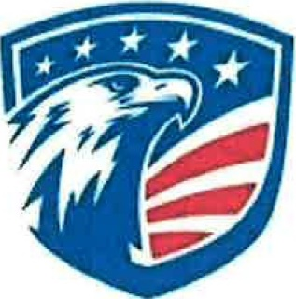
Smart Snacks in Schools Six Day Exemption Form

School: Stacey High School & Lackland Elementary Principal: Mr. Shelby Hunter & Mrs. Terry Leija
As per the Smart Snacks in school's regulation, Lackland ISD has 6 exemption days that may allow the sale of food and beverages that do not meet Smart Snacks regulations (candy bars, sodas etc.) during the school day for fundraising purposes.

The exempted days must be approved by the District Superintendent or his/her designee. During these days, non-Smart Snack fundraising foods or beverages may not be sold during mealtimes, or in the areas where school meals are being served or consumed, and regular meal service (breakfast and lunch) must continue to be available to all students in accordance with federal regulations. The dates you post below are the ONLY dates that non-Smart Snack foods and beverages can be made available to students on your campus. The exemption will apply campus-wide across all grade levels.

NOTE: A common question about the event day exemption is whether individual schools can spread the event day across more than one day to be able to accommodate different grade levels. This is not an acceptable interpretation of the guidelines. An approved exemption day counts as a waiver day for the whole campus, so all concerned organizations must plan accordingly.
Please list for the current school year the six school dates that will be exempt from the Smart Snacks in Schools regulations.

- October 8, 2021
- November 17, 2021
- December 15, 2021
- February 14, 2022
- March 8, 2022
- April 14, 2022

_____________________________ ______________________
Mr. Hunter Shelby, Principal Date

_____________________________ ______________________
Mrs. Teresa Leija, Principal Date

_____________________________ ______________________
Dr. Burnie L. Roper, Superintendent Date

Signed copy dated September 27, 2021 on file.

