WELLNESS PLAN
This document, referred to as the “wellness plan” (the plan), is intended to implement policy FFA(LOCAL), which has been adopted by the Board, to comply with the requirements for a school wellness policy. [Section 9A (a) of the National School Lunch Act (NSLA), 42 U.S.C. 1758b]

STRATEGIES TO SOLICIT INVOLVEMENT
Federal law requires that certain stakeholders be involved in the development, implementation, and periodic review and update of the wellness policy. The District has chosen to use the local school health advisory council (SHAC) to work on behalf of the District to review and consider evidence-based strategies and techniques in order to develop and implement nutrition guidelines and wellness goals as required by federal law. The SHAC will permit the following persons to work with the SHAC on the District’s wellness policy and plan: parents, students, the District’s food service personnel, physical education teachers, school health professionals, Board members, administrators, and members of the public. The SHAC will solicit the involvement and input of these other interested persons by:
- Formally requesting participation and providing contact information of person(s) responsible for the oversight of the District’s SHAC and wellness policy and plan development.
- Publicizing the opportunity to engage in matters of the SHAC on the website and in other district publications

IMPLEMENTATION
Each campus principal is responsible for the implementation of FFA (LOCAL) and this wellness plan at his or her campus, including the submission of necessary information to the SHAC for evaluation.
The Superintendent is the District official responsible for the overall implementation of FFA (LOCAL), including the development of this wellness plan and any other appropriate administrative procedures, and ensuring that each campus complies with the policy and plan.

EVALUATION
In accordance with law, the District will periodically measure and make available to the public an assessment of the implementation of the District’s wellness policy, the extent to which each campus is compliant with the wellness policy, a description of the progress made in attaining the goals of the wellness policy, and the extent to which the wellness policy compares with any state- or federally designated model wellness policies. Absent federal regulations to the contrary, the District commits to the evaluation activities described below.
At least annually, the SHAC will prepare a report on the wellness policy and this plan by gathering information from each principal and appropriate District administrators. The SHAC will assess the District’s and each campus’s progress toward meeting the goals of the policy and plan by reviewing District- and campus-level activities and events tied to the wellness program.
The SHAC may use one or more of the following tools for that analysis:
- A comprehensive review of district and campus-level activities and events tied to the wellness program.
- Stakeholder input
- Annual audits to measure alignment with defined actions steps, available resources, and specified evidence of success.

PUBLIC NOTIFICATION
To comply with the legal requirement to inform and update the public about the content and implementation of the local wellness policy, the District will maintain a wellness page on its website to document information and activity related to the school wellness policy, including:
- A copy of the wellness policy [see FFA(LOCAL)];
- A copy of this wellness plan, with dated revisions;
- Notice of any Board revisions to policy FFA(LOCAL);
- Notice of any SHAC meeting at which the wellness policy or corresponding documents are scheduled to be discussed;
- The SHAC’s annual report on the District’s wellness policy and plan; and
- Any other relevant information.
The District will also publish the above information in appropriate District or campus publications.

RECORDS RETENTION
Records regarding the District’s wellness policy will be retained in accordance with law and the District’s records management program. Questions may be directed to the Chief Financial Officer, the District’s designated records management officer.

GUIDELINES AND GOALS
The following provisions describe the District’s nutrition guidelines and activities and objectives chosen by the SHAC to implement the Board-adopted wellness goals in policy FFA (LOCAL).

NUTRITION GUIDELINES
All District campuses participate in the U.S. Department of Agriculture’s (USDA’s) child nutrition programs, including the National School Lunch Program (NSLP) and the School Breakfast Program (SBP). Federal law requires that the District establish nutrition guidelines for foods made available on each campus that are consistent with the federal standards and that promote student health and reduce childhood obesity.
The District’s nutrition guidelines are to ensure all foods and beverages sold, otherwise made available, or marketed to students during the school day adhere to all federal regulations and guidance and are designed to promote student health and reduce childhood obesity. The school day is defined as the time period beginning at midnight until 30 minutes after the last bell.

FOODS SOLD
The District will comply with federal requirements for reimbursable meals. For other foods and beverages sold to students during the school day, the District will comply with the federal requirements for competitive foods. Competitive foods and beverages are not part of the regular meal programs and occur through sales such as a la carte options or vending machines. For purposes of this plan, these requirements will be referred to as “Smart Snacks” standards or requirements. The following websites have information regarding meal and Smart Snacks requirements:
- http://www.fns.usda.gov/school-meals/nutrition-standards-school-meals
- http://www.fns.usda.gov/healthierschoolday/tools-schools-focusing-smart-snacks
- http://www.squaremeals.org/Publications/Handbooks.aspx

EXCEPTION—FUNDRAISERS
State rules adopted by the Texas Department of Agriculture (TDA) allow an exemption to the Smart Snacks requirements for up to six days per year per campus when a food or beverage is sold as part of a District fundraiser. [See CO (LEGAL).]
The District will allow the following exempted fundraisers for the 2016-17, 2017-18, 2018-2019, 2019-2020, 2020-2021, 2021-2022 school years: 21-22 days are linked here.
Campus or Organization | Food / Beverage | Number of Days
Lackland Elementary School | Food and Beverages | Six days
Stacey Jr./Sr. High School | Food and Beverages | Six days

FOODS MADE AVAILABLE
There are currently no federal requirements for foods or beverages made available to students during the school day. The District will comply with state law, which allows a parent or grandparent to provide a food product of his or her choice to classmates of the person’s child or grandchild on the occasion of the student’s birthday or to children at a school-designated function. [See CO (LEGAL).]
The district will share with parents and grandparents the preference for pre-packaged and store bought materials that identify ingredients to ensure the safety of students with food related allergies.
In addition, the District provides that with the exception of exemption days, foods and beverages made available to students shall be approved by the campus principal. Students will not have access to vending machines containing items that are not considered smart snacks.

MEASURING COMPLIANCE
The District will measure compliance with the nutrition guidelines by reviewing meal reimbursement submissions from the child nutrition department to the TDA, reviewing foods and beverages that are sold in competition with the regular school meals, reviewing items sold as part of approved District fundraisers, and monitoring the types of foods and beverages made available to students during the school day.

NUTRITION PROMOTION
Federal law requires that the District establish goals for nutrition promotion in its wellness policy. The District’s nutrition promotion activities will encourage participation in the National School Lunch Program, the School Breakfast Program, and any supplemental food and nutrition programs offered by the District.
In accordance with FFA (LOCAL), the District has established the following goal(s) for nutrition promotion.
GOAL I: The District’s food service staff, teachers, and other District personnel shall consistently promote healthy nutrition messages in cafeterias, classrooms, and other appropriate settings.
Objective 1:
Action Steps | Methods for Measuring Implementation
The school district will display posters and wall art in the cafeteria, classrooms, and hallways that promote nutritious eating habits and overall healthy lifestyles. | Resources needed:  - Posters  - Schedule for postings  Evidence of Success:  - Artifacts of posted materials
2021-2022 Evaluation Comments: (Hyde)
Materials posted throughout the hallways include nutritious eating habits and ways to promote healthy lifestyles:

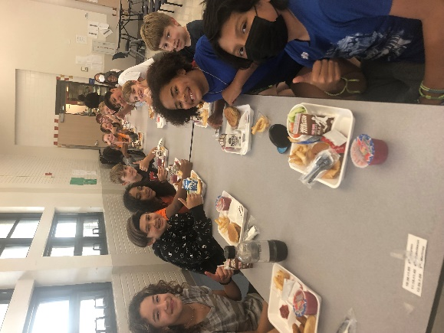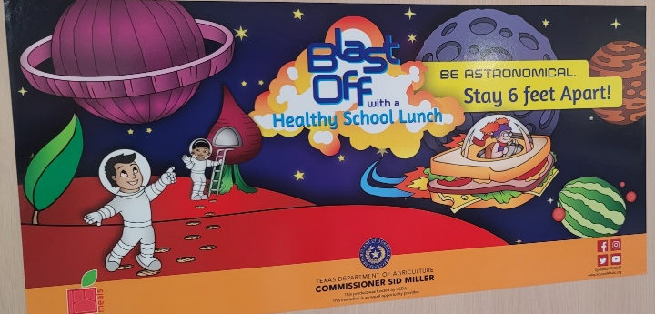

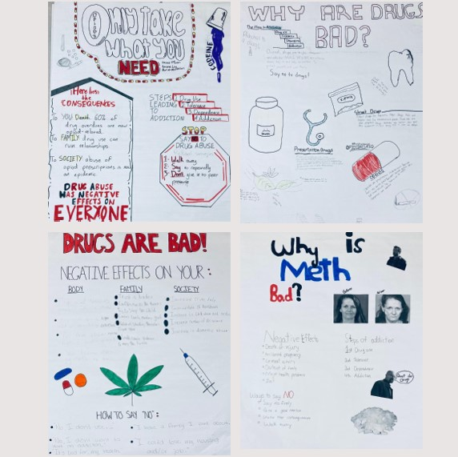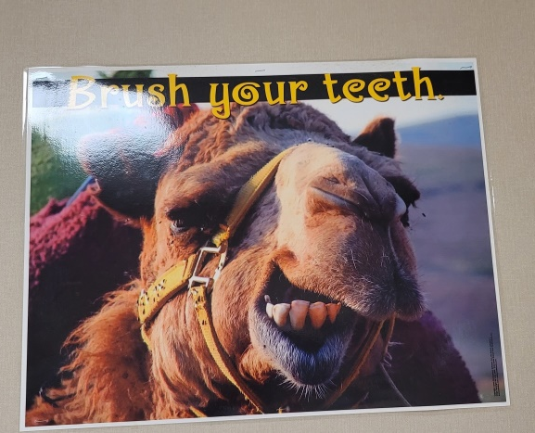

GOAL II: The District shall share educational nutrition information with families and the general public to promote healthy nutrition choices and positively influence the health of students.
Objective 1:
Action Steps | Methods for Measuring Implementation
Nutrition information will be posted on the district website. | Resources needed:  - Annual SHAC assessment tool  Evidence of Success:  - Documentation of postings
2021-2022 Evaluation Comments: (Concha and Hyde)
The Child Nutrition website at https://www.lacklandisd.net/departments/operations/child-nutrition-services is updated frequently to share timely information.

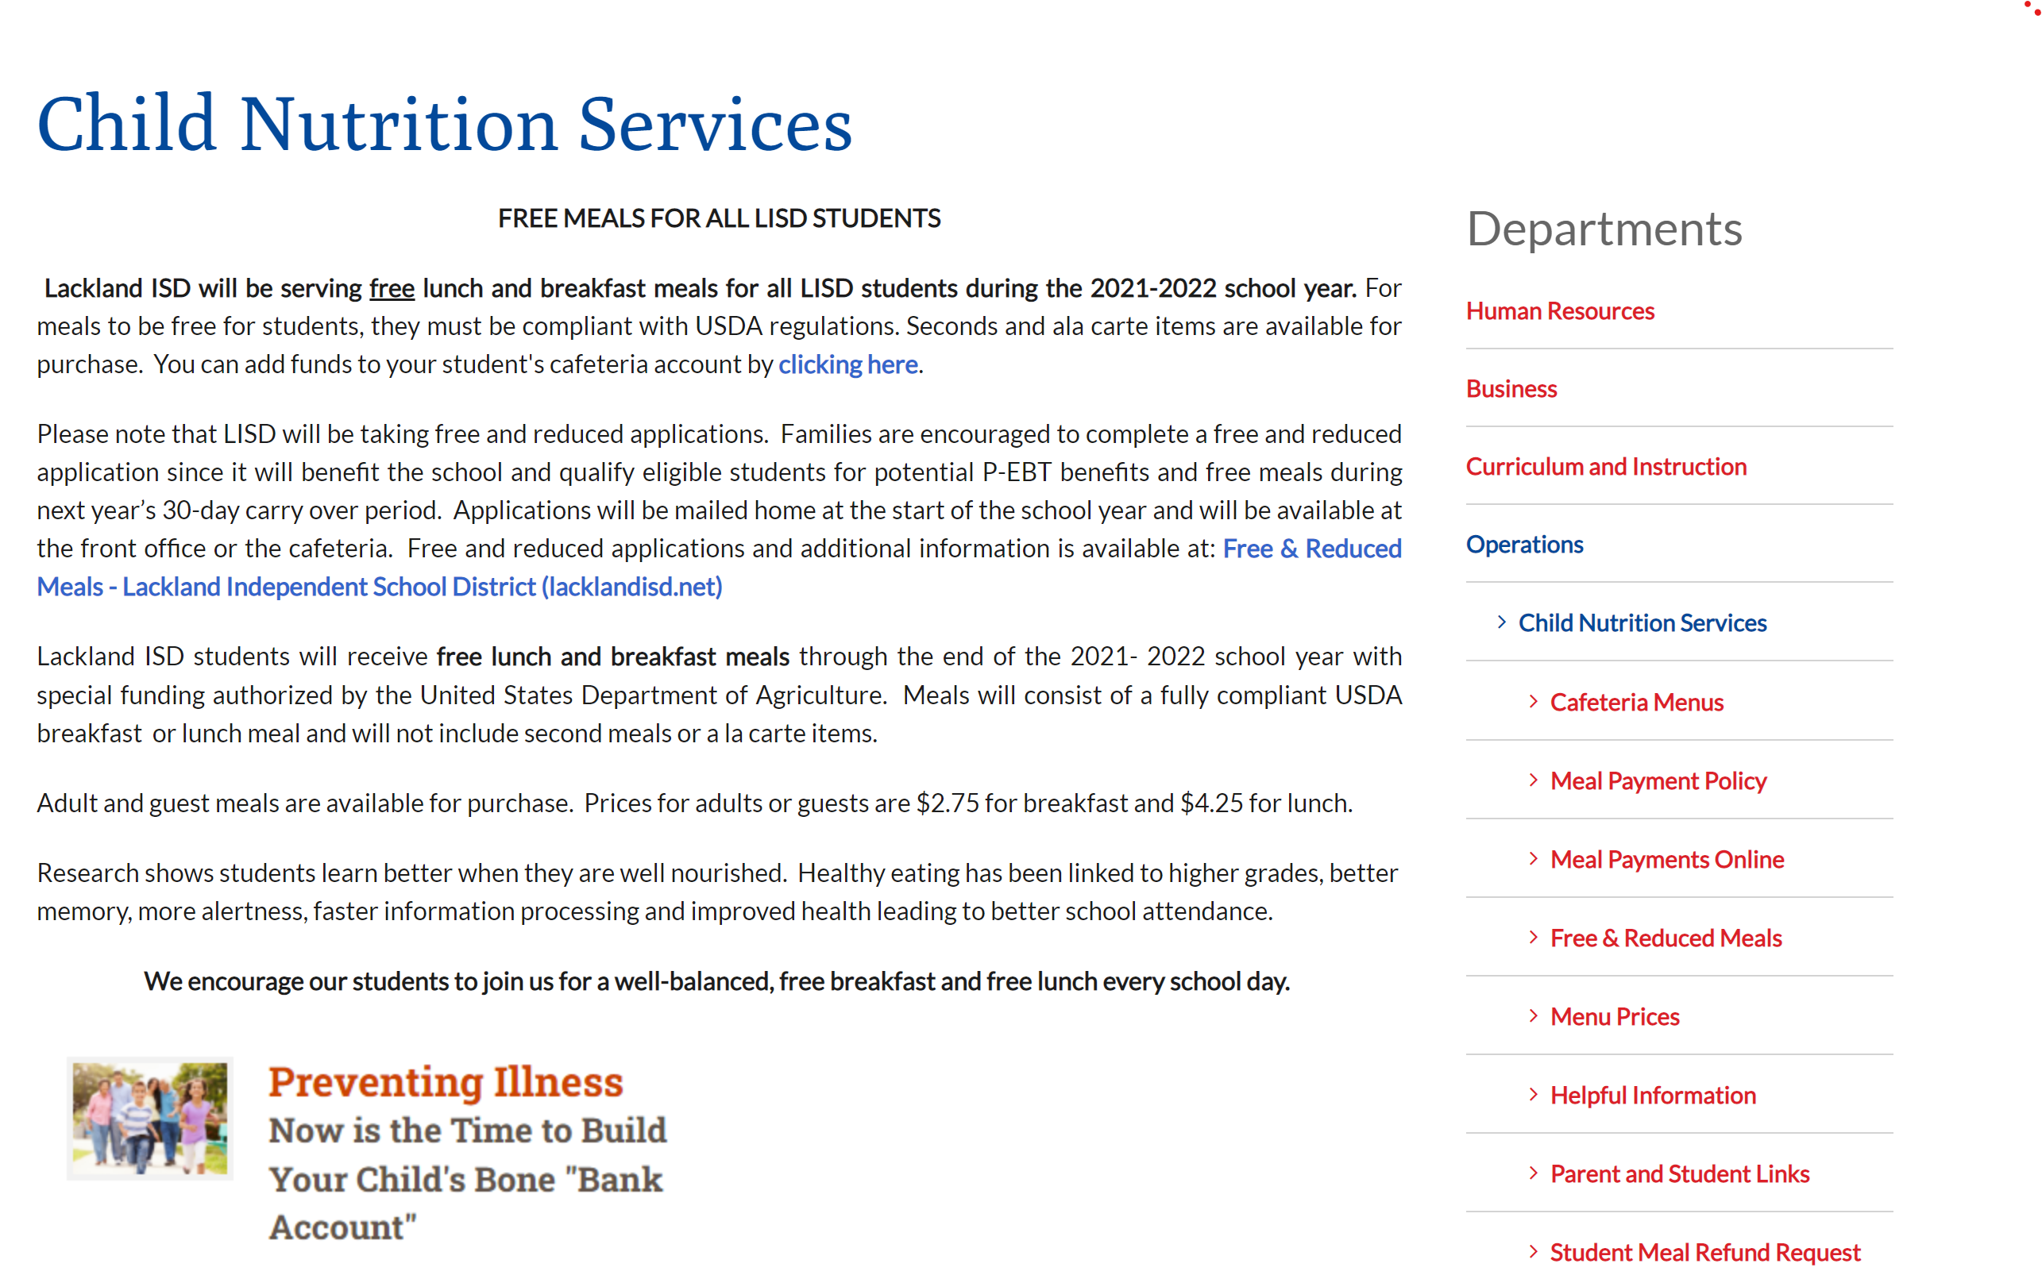

NUTRITION EDUCATION
Federal law requires that the District establish goals for nutrition education in its wellness policy. State law also requires that the District implement a coordinated health program with a nutrition services and health education component at the elementary and middle school levels. [See EHAA.]
For compliance with the state requirement to implement TEA-approved coordinated school health programs, the District implements a locally-designed coordinated health program.
In accordance with FFA (LOCAL), the District has established the following goal(s) for nutrition education.
GOAL III: The District shall deliver nutrition education that fosters the adoption and maintenance of healthy eating behaviors.
Objective 1:
Action Steps | Methods for Measuring Implementation
Ensure full implementation of Texas Education Agency (TEKS) objectives in science, health, and physical education using integrated approach. | Resources needed:  - TEKS based activities  Evidence of Success  - Lesson Plans  - Artifacts of activities
Incorporate instruction in high school health course | Resources needed:  - Text and/or curriculum materials  Evidence of Success  - Lesson Plans  - Artifacts of activities
2021-2022 Evaluation Comments: (Rigney and Hyde)

Elementary health instruction is embedded in the health and physical education program curriculum and science curriculum. Secondary health instruction is embedded in the health and physical education program, science curriculum, and, health program curriculum. Teacher lesson plans incorporate appropriate TEKS-based activities regarding the importance of healthy eating. Students also receive additional information through age-appropriate posted literature, and handouts.

GOAL IV: The District shall make nutrition education a District-wide priority and shall integrate nutrition education into other areas of the curriculum, as appropriate.
Objective 1:
Action Steps | Methods for Measuring Implementation
Ensure implementation of nutrition education in activities and other related curriculum offerings. | Resources needed:  - List of planned activities and nutrition-related opportunities to include  National School Breakfast Week and National Nutrition Month  Evidence of Success:  - Logs and artifacts of activities offered
2021-2022 Evaluation Comments: (Concha)

The child nutrition program participates in events such as the National School Breakfast Week and National School Lunch Week program throughout the year. Nutritional events are also linked to monthly cultural recognitions. Lackland ISD allocates local funds to provide free breakfast to all students and free milk to any students who bring lunch from home.

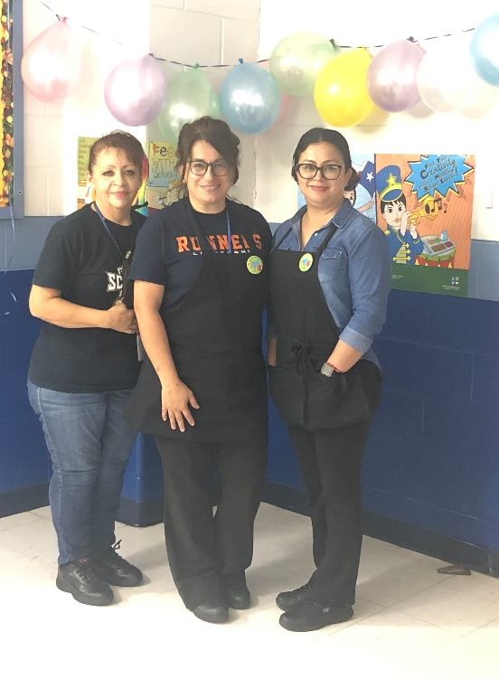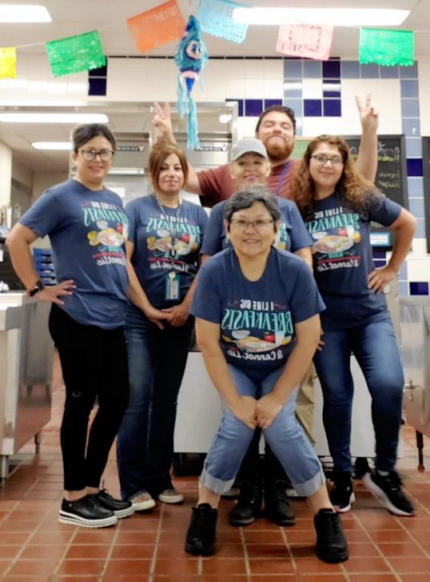

GOAL V: The District shall provide professional development so that teachers and other staff responsible for the nutrition education program are adequately prepared to effectively deliver the program.
Objective 1:
Action Steps | Methods for Measuring Implementation
Identify food service and instructional personnel to receive training specific to their assignments. | Resources needed:  - Allocation of time to complete training  - Training appropriate to identified needs  - Funds to compensate hourly employees for completion of training and professional development outside of their duty schedule, as appropriate  Evidence of Success:  - Professional development agendas  - SafeSchools training logs
2021-2022 Evaluation Comments:

The Director of Operations and Child Nutrition Program leaders determine required and recommended training opportunities through online modules and in-person sessions. Professional development for child nutrition staff meets state and federal requirements.

Health and Science teachers participate in professional development opportunities aligned with their curriculum throughout the school year and as scheduled.

Objective 2:
Action Steps | Methods for Measuring Implementation
Identify opportunities to provide intentional instruction and discussions about age-appropriate health and nutrition practices throughout all academic areas. | Resources needed:  - Scope and Sequence documents that show when instruction will be provided  Evidence of Success:  - Artifacts of completed activities  - Lesson plans
2021-2022 Evaluation Comments:

Curriculum scope and sequence documents share when specific health and nutrition topics are incorporated into lessons and activities. Documents are currently housed in TEAMs and on the learning management platform, Canvas.

PHYSICAL ACTIVITY
The District will implement, in accordance with law, a coordinated health program with physical education and physical activity components and will offer at least the required amount of physical activity for all grades. [See BDF, EHAA, EHAB, and EHAC.]
Students will meet the required physical activity minutes in assigned physical education classes. Elementary students will receive according to campus schedule either a minimum of 30 minutes of daily physical activity or 135 minutes of physical activity weekly. Secondary students will enroll in a physical education or athletics course for at least four semesters at the middle school level.
Federal law requires that the District establish goals for physical activity in its wellness policy.
In accordance with FFA (LOCAL), the District has established the following goal(s) for physical activity.

GOAL VI: The District shall provide an environment that fosters safe, enjoyable, and developmentally appropriate fitness activities for all students, including those who are not participating in physical education classes or competitive sports.
Objective 1:
Action Steps | Methods for Measuring Implementation
Provide opportunities for students to participate in unstructured activities during lunch including but not limited to outdoor eating, walking, and physical activity. | Resources needed:  - Teacher and staff supervision  - Schedule reflecting open gym opportunities  Evidence of Success:  - Logs of student participation per activity
2021-2022 Evaluation Comments:
During lunch, students may eat indoors or outdoors and walk and expend energy after they finish eating.

GOAL VII: The District shall provide appropriate staff development and encourage teachers to integrate physical activity into the academic curriculum where appropriate.
Objective 1:
Action Steps | Methods for Measuring Implementation
Provide strategies and a bank of activities that incorporate movement decreasing prolonged periods of being sedentary. | Resources needed:  - Time  - Bank of Activities  Evidence of Success:  - Identified opportunities used to increase physical activity during instructional blocks and transitions
2021-2022 Evaluation Comments:
Teachers provide opportunities for movement and engagement in physical activities routinely in their lesson cycles. Students are encouraged to participate. At the elementary school, Go Noodle (www.gonoodle.com) is a favorite medium to provide brain breaks. Opportunities are provided for outdoor instruction. Elementary and Secondary school teachers continue using mindful movement as part of the Breathe for Change initiative.

Objective 2:
Action Steps | Methods for Measuring Implementation
Implement strategies to encourage students to engage in physical activity during recess. | Resources needed:  - Bank of strategies  - Supplies (jump ropes, balls, etc.)  - Identified areas for physical activity  Evidence of Success:  - Artifacts of student participation in physical activity during recess  - Emphasis on the importance of not taking recess away as a punishment or for work completion.
2021-2022 Evaluation Comments:
Teachers use various tools from their classroom outdoor equipment supplies to engage students in physical activity, including joining them in fun. Students also have opportunities to participate in non-structured activities.

GOAL VIII: The District shall make appropriate training and other activities available to District employees in order to promote enjoyable, life-long physical activity for District employees and students.
Objective 1:
Action Steps | Methods for Measuring Implementation
Incorporate brain-based and physical activities into staff training and professional development opportunities emphasizing the need to make it a natural part of our practice. | Resources needed:  - Time in the professional development schedule  - Posters of activities for teachers to use in their classroom  Evidence of Success:  - Artifacts of training and professional development offerings
2021-2022 Evaluation Comments:
The staff attends professional development such as AVID, SFA, Brain-Based Learning, Differentiated Instruction, Breathe for Change, Blended Learning and New to Lackland Teacher Induction and Mentoring. These professional development opportunities incorporate movement models and engage staff in using strategies to embed movement in learning in accordance with student age.

GOAL IX: The District shall encourage parents to support their children’s participation, to be active role models, and to include physical activity in family events.
Objective 1:
Action Steps | Methods for Measuring Implementation
Continue the practice of offering physical fitness-related family engagement activities | Resources needed:  - Encouraged use of incentives appropriate to grade level.  - Calendar of opportunities.  Evidence of Success:  - Participation logs and artifacts
2020-2021 Evaluation Comments:

Physical fitness activities were limited due to Covid-19 restrictions, however, a painting with a parent wellness activity and family Zumba night were offered as part of the Let’s Talk Series for family engagement.

GOAL X: The District shall encourage students, parents, staff, and community members to use the District’s recreational facilities, such as tracks, playgrounds, and the like, that are available for use outside the school day.
Objective 1:
Action Steps | Methods for Measuring Implementation
Post and publicize the opportunity for community use of recreational facilities during non-school hours and scheduled activities on the district website and in other prominent places. | Resources needed:  - Website posting  - E-newsletter publications  - Maintenance of equipment  Evidence of Success:  - Artifacts of community use  - Artifacts of postings
2021-2022 Evaluation Comments:
The LISD track was resurfaced this year providing a safer experience for community use when walking. Signs are posted to share responsible use guidelines.

GOAL XI: The District shall daily provide for elementary school students the appropriate time, supervision, facilities, and equipment necessary for a safe, productive, unstructured, and enjoyable recess period when weather and modified schedules permit.
Objective 1:
Action Steps | Methods for Measuring Implementation
Publish a recess schedule that identifies time and location of recess for each class. | Resources needed:  - Master schedule  - Appropriate number of recess areas  - Teacher collaboration to determine use of specific recess locations  Evidence of Success:  - Student engagement in recess  - Teacher full implementation of schedules
2021-2022 Evaluation Comments:
Schedules are available, reflecting the time for recess. Teachers collaborate as needed to determine the location for recess. Playgrounds are available for student use and are sanitized after each class use.

Objective 2:
Action Steps | Methods for Measuring Implementation
Provide resources for equipment to allow for physical activity options at recess | Resources needed:  - Budget to maintain and add new equipment  Evidence of Success:  - Teacher use of budget allocations to secure materials relevant to their students
2021-2022 Evaluation Comments:
Teachers purchase materials based on student interests and ongoing use. More materials are available due to limited ability to share during COVID-19 restrictions.

SCHOOL-BASED ACTIVITIES
Federal law requires that the District establish goals for other school-based activities in its wellness policy to promote student wellness.
In accordance with FFA (LOCAL), the District has established the following goal(s) as part of its student wellness policy to create an environment conducive to healthful eating and physical activity and to promote and express a consistent wellness message.

GOAL XII: The District shall allow sufficient time for students to eat meals in cafeteria facilities that are clean, safe, and comfortable.
Objective 1:
Action Steps | Methods for Measuring Implementation
Master schedules allot 30 minutes for lunch. A minimum of 15 minutes of this time will be used for food consumption. | Resources needed:  - Master schedule  Evidence of success:  - Student use of time
2021-2022 Evaluation Comments:

Lunch schedules and support staff were adjusted to provide a 30-minute lunchtime with a minimum of 15 minutes for food consumption specifically when services were impacted by covid-19 protocols.

GOAL XIII: The District shall promote employee wellness activities and involvement at suitable District and campus activities.
Objective 1:
Action Steps | Methods for Measuring Implementation
Share and encourage staff engagement in wellness activities such as District yoga and cardio exercise opportunities, fitness challenges, and Wellness Wednesday publications. | Resources needed:  - Funds  - Continued Wellness Wednesday Publications  Evidence of Success:  - Staff Participation
2021-2022 Evaluation Comments: (Conte)
Three opportunities are offered to staff and include cardio and strength, Zumba, and yoga. The facilitators are Mrs. Conte, Ms. Coffey, and Ms. Dominguez. Staff participation averaged from one to six attending consistently.

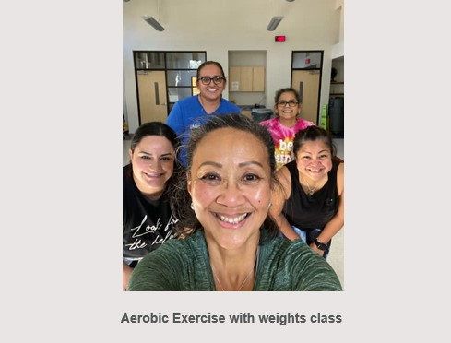
Objective 2:
Action Steps | Methods for Measuring Implementation
Ensure availability of appropriate exercise facilities by upgrading staff exercise room facilities | Resources needed:  - Funds to fix, upgrade, and update equipment  Evidence of Success:  - Staff use  - Maintenance logs
2021-2022 Evaluation Comments: (Conte)
The teams used the TRAC for cardio and strength and yoga. Zumba was in the music room. Participants expressed enjoying the classes and the benefits of their efforts.

The staff has used the exercise room.

Ms. Coffey plans to continue to offer Zumba classes next school year.

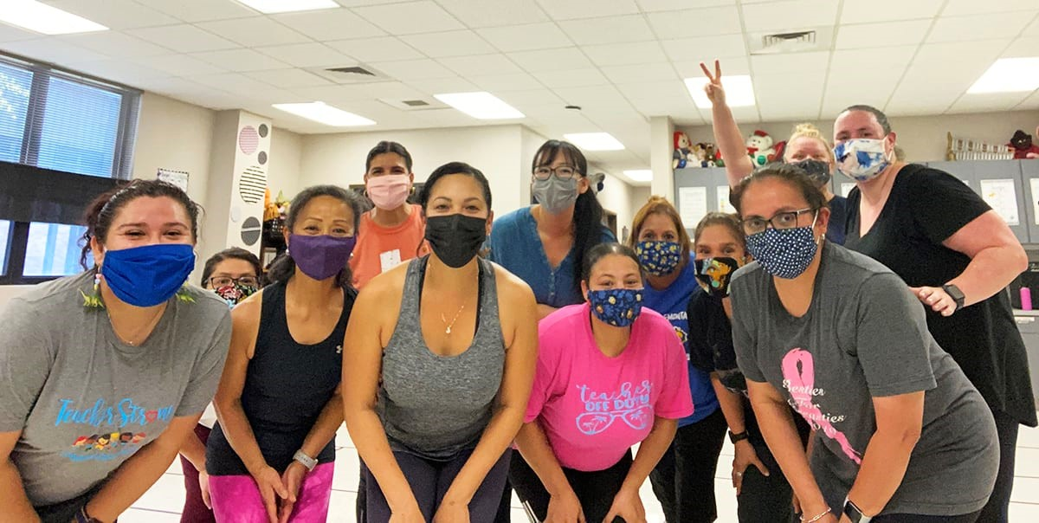

Objective 3:
Action Steps | Methods for Measuring Implementation
Identify alternative spaces for staff engagement in physical activity | Resources needed:  - Availability of spaces  - List of potential spaces to include the TRAC, Lyon Center, cafeterias, etc.  Evidence of Success:  - Staff participation logs  - List of spaces utilized
2021-2022 Evaluation Comments:
Staff uses equipment in the staff workout room. They also have opportunities to engage in facilitated physical activities in the TRAC, music room, and on the LISD track. JBSA facilities are also open to staff as permitted with Covid-19 restrictions.

